**LABORATORY PROGRAM - 1**

Develop a Java program that prints all real solutions to the quadratic equation ${ax}^{2}+bx+c=0$  
. Read in a, b, c and use the quadratic formula. If the discriminant $b^{2}-4ac$ is negative, display a message stating that there are no real solutions.

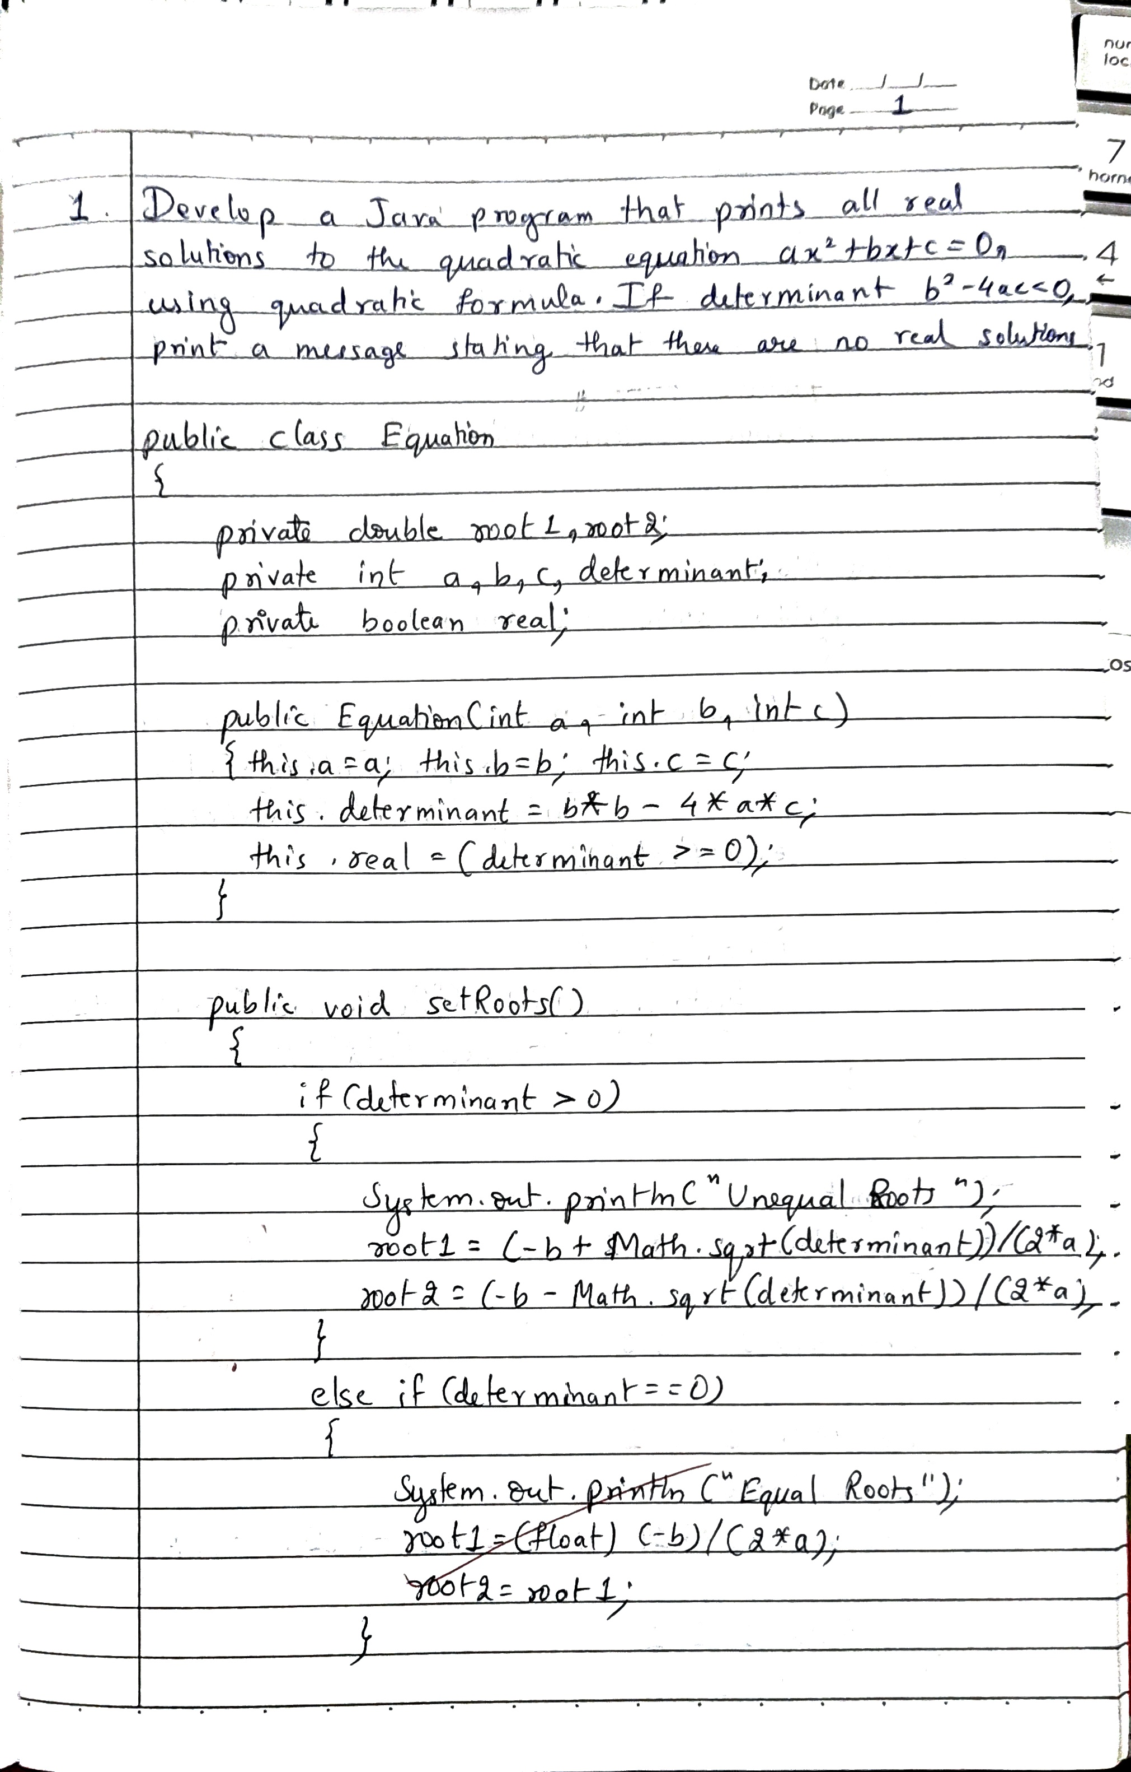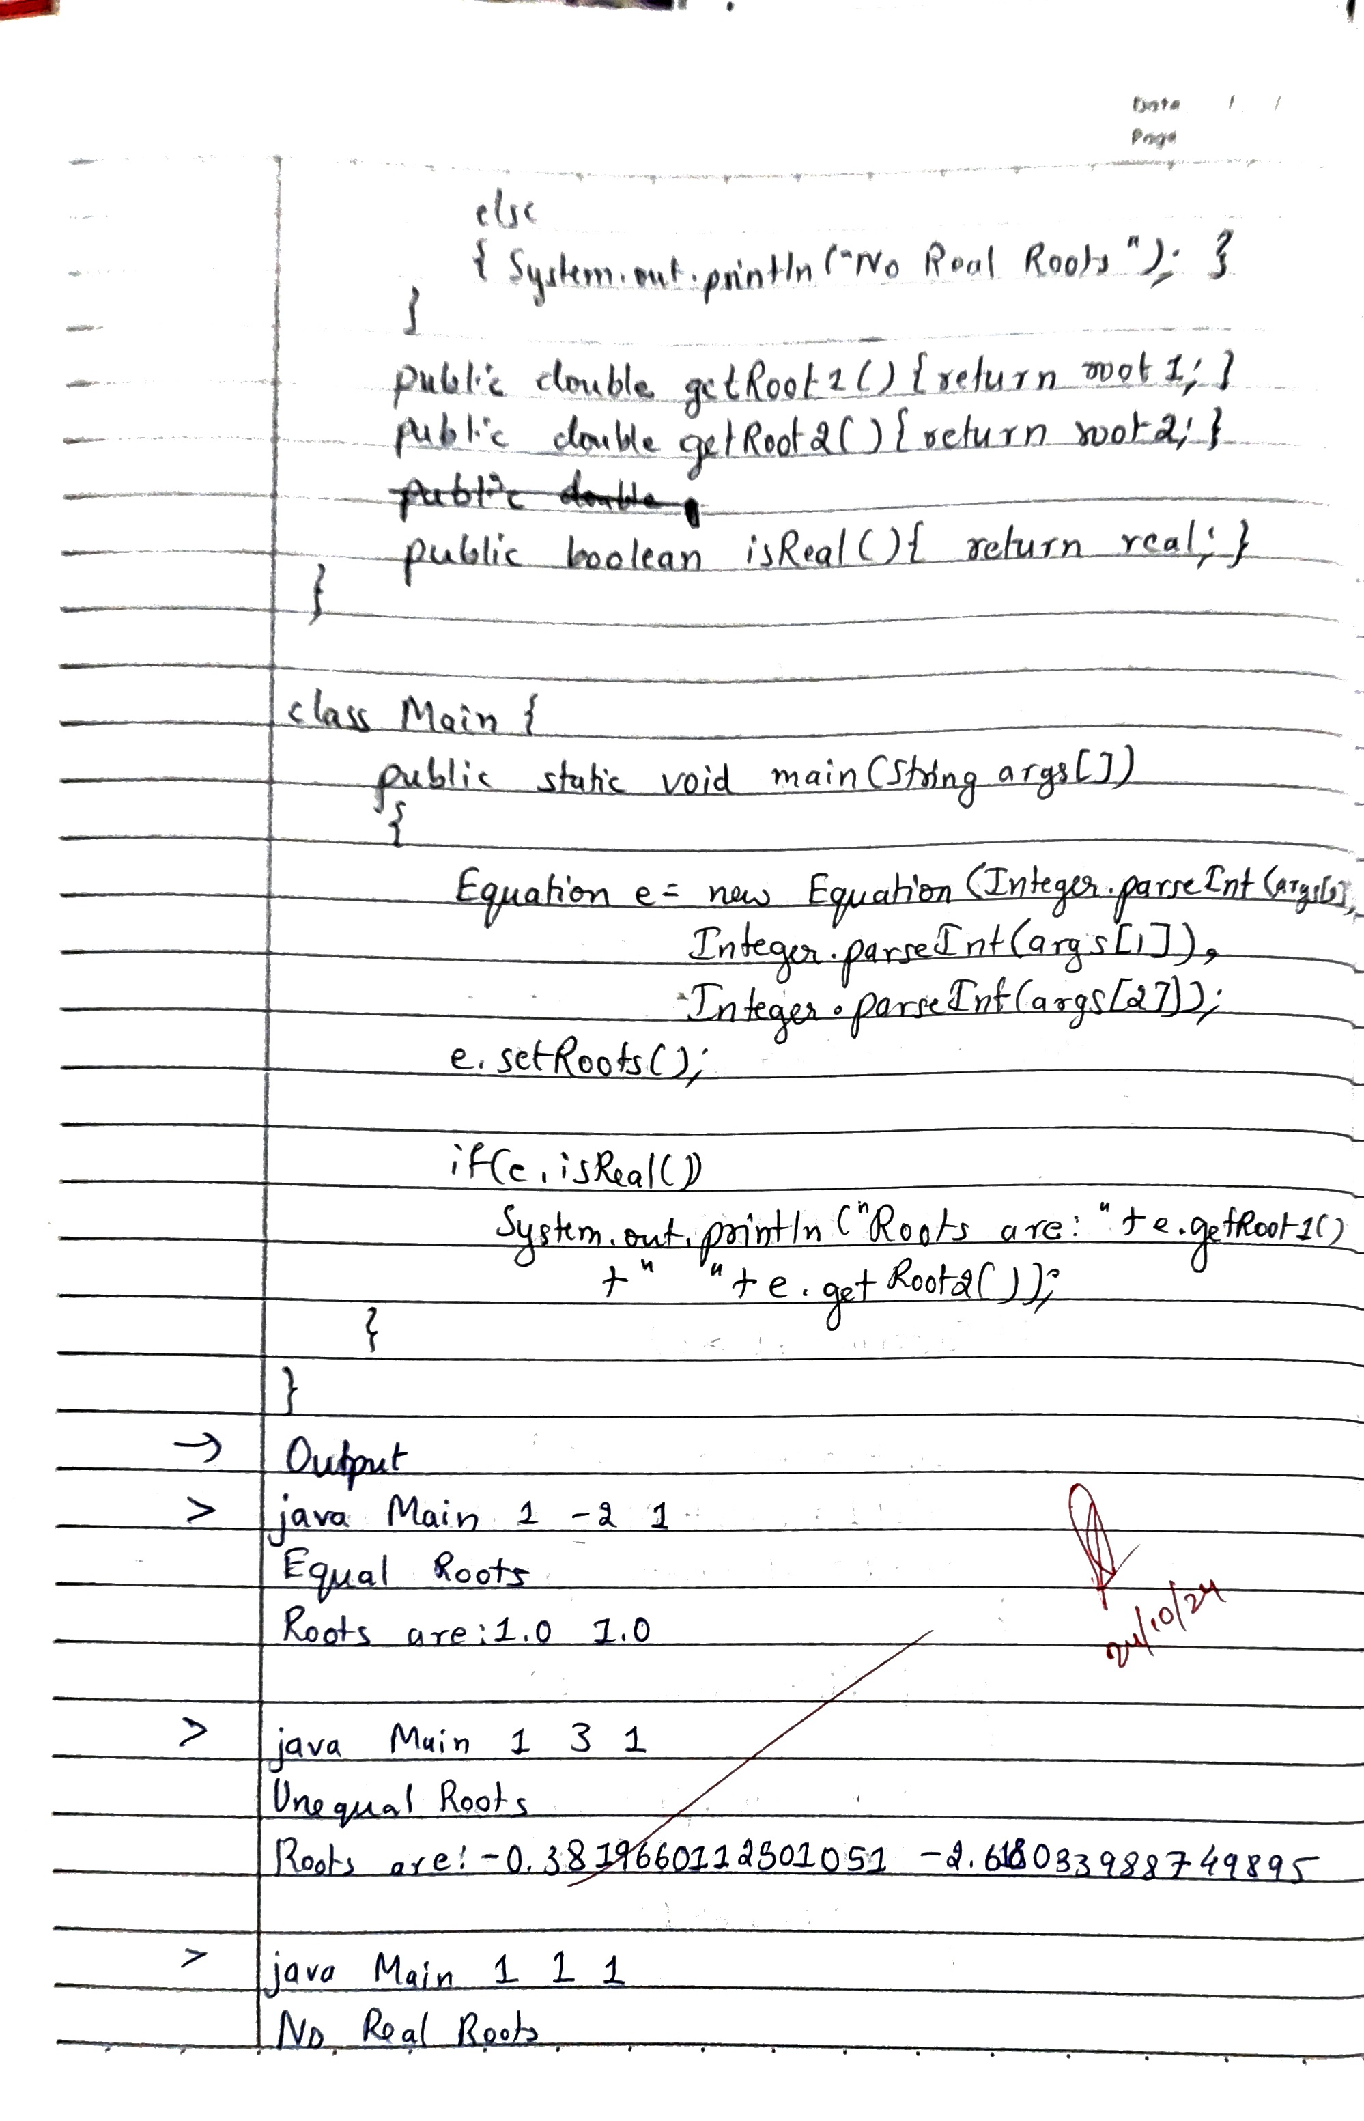

**Code:**

**public class Equation{**

**private double root1;**

**private double root2;**

**private int a;**

**private int b;**

**private int c;**

**private int determinant;**

**private boolean real;**

**public Equation (int a, int b, int c){**

**this.a=a;**

**this.b=b;**

**this.c=c;**

**this.determinant=b*b-4*a*c;**

**real=determinant>=0;**

**}**

**public void setRoots(){**

**if (determinant>0){**

**System.out.println("Unequal Roots");**

**root1=(-b+Math.sqrt(determinant))/(2*a);**

**root2=(-b-Math.sqrt(determinant))/(2*a);**

**}**

**else if (determinant==0){**

**System.out.println("Equal Roots");**

**root1=(float)(-b)/(2*a);**

**root2=root1;**

**}**

**else{**

**System.out.println("No Real Roots");**

**}**

**}**

**public double getRoot1(){**

**return root1;**

**}**

**public double getRoot2(){**

**return root2;**

**}**

**public boolean isReal(){**

**return real;**

**}**

**}**

**class Main{**

**public static void main(String args[]){**

**Equation e=new Equation(Integer.parseInt(args[0]), Integer.parseInt(args[1]), Integer.parseInt(args[2]));**

**e.setRoots();**

**if (e.isReal())**

**System.out.println("Roots are:"+e.getRoot1()+" "+e.getRoot2());**

**}**

**}**

**OUTPUT**

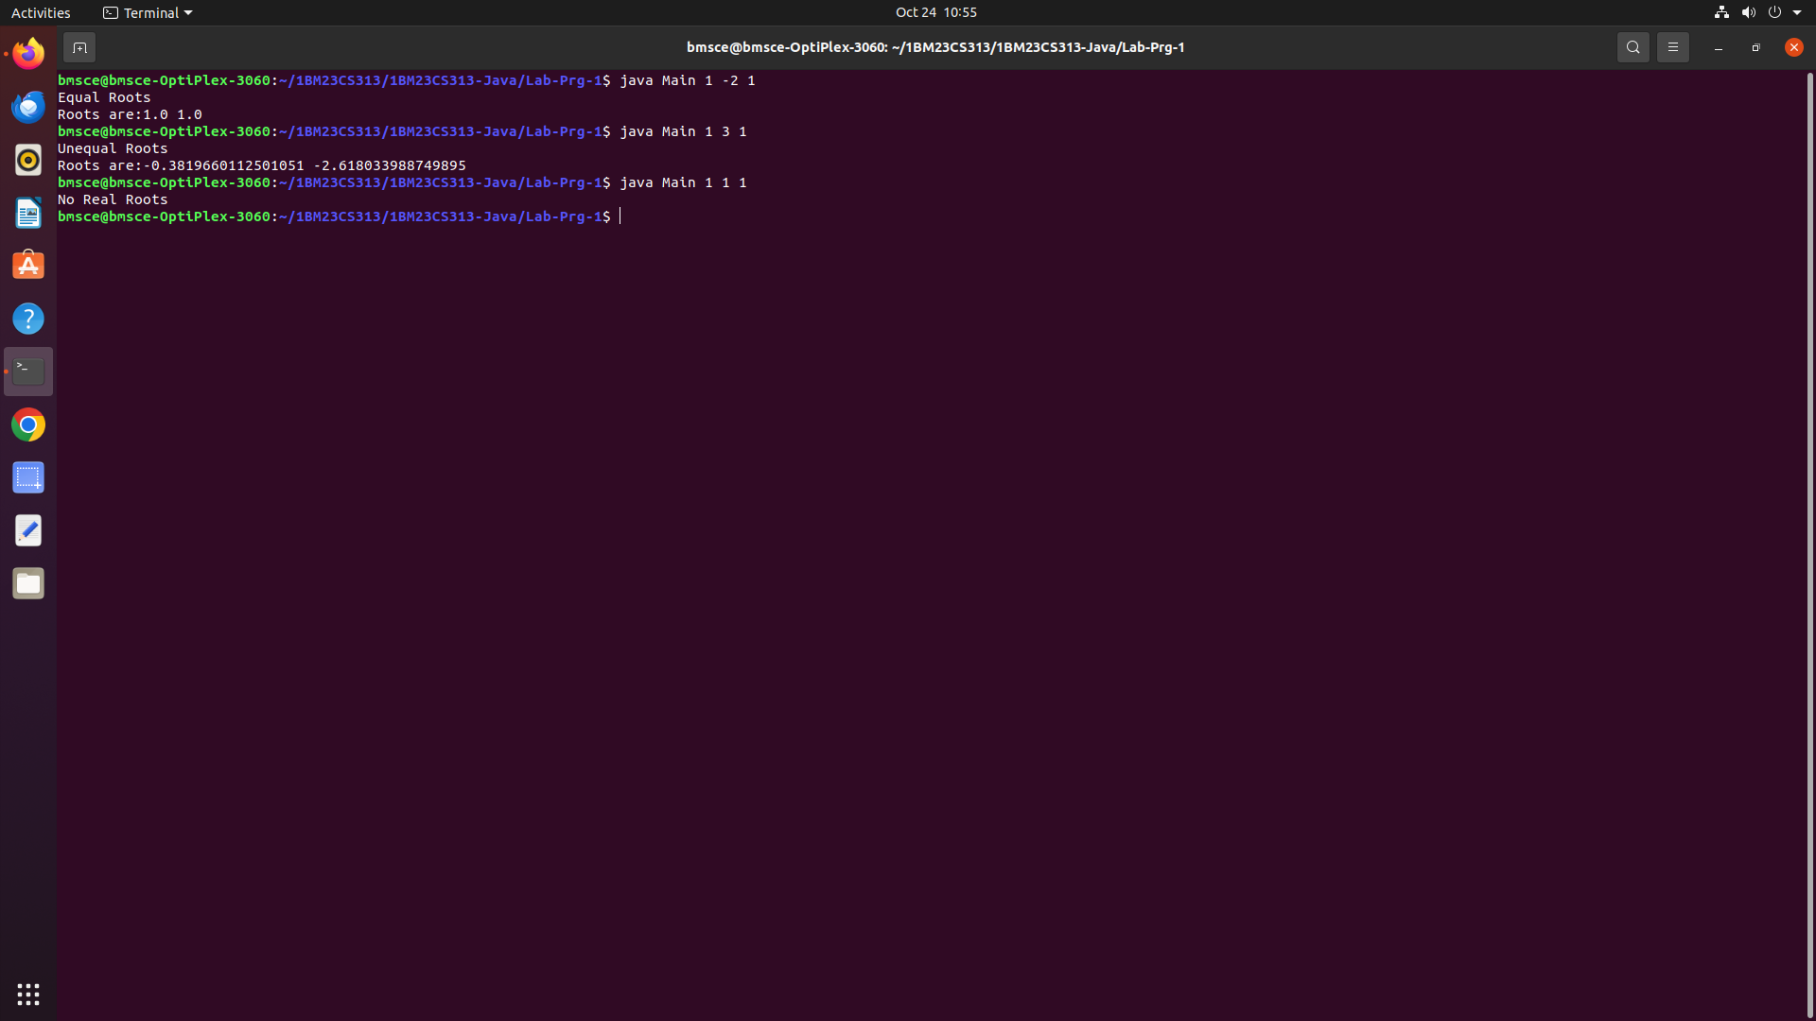

**LABORATORY PROGRAM - 2**

Develop a Java program to create a class Student with members usn, name, an array credits and an array marks. Include methods to accept and display details and a method to calculate SGPA of a student.

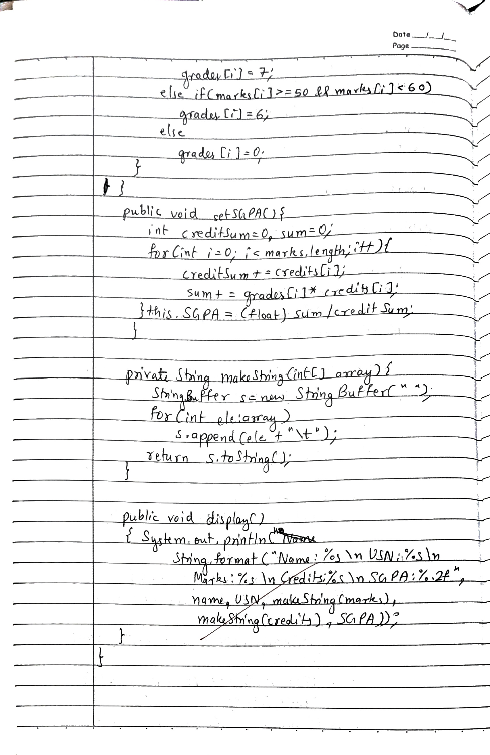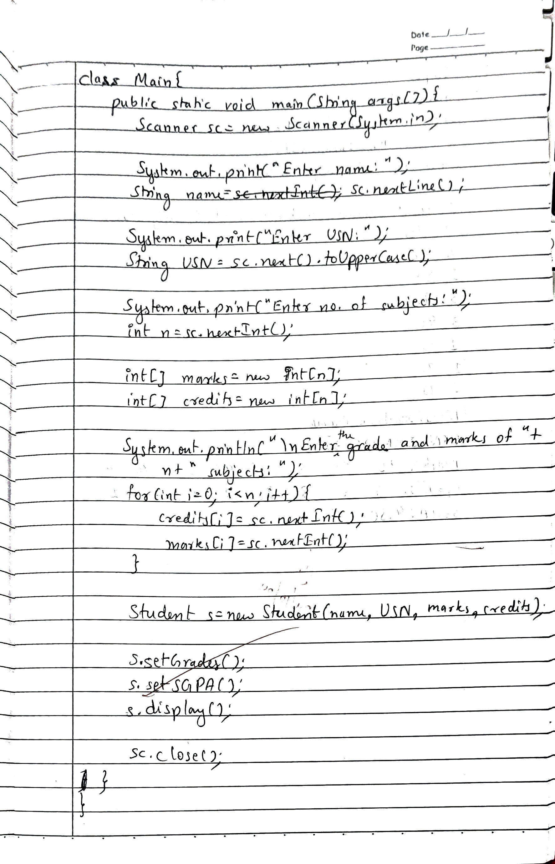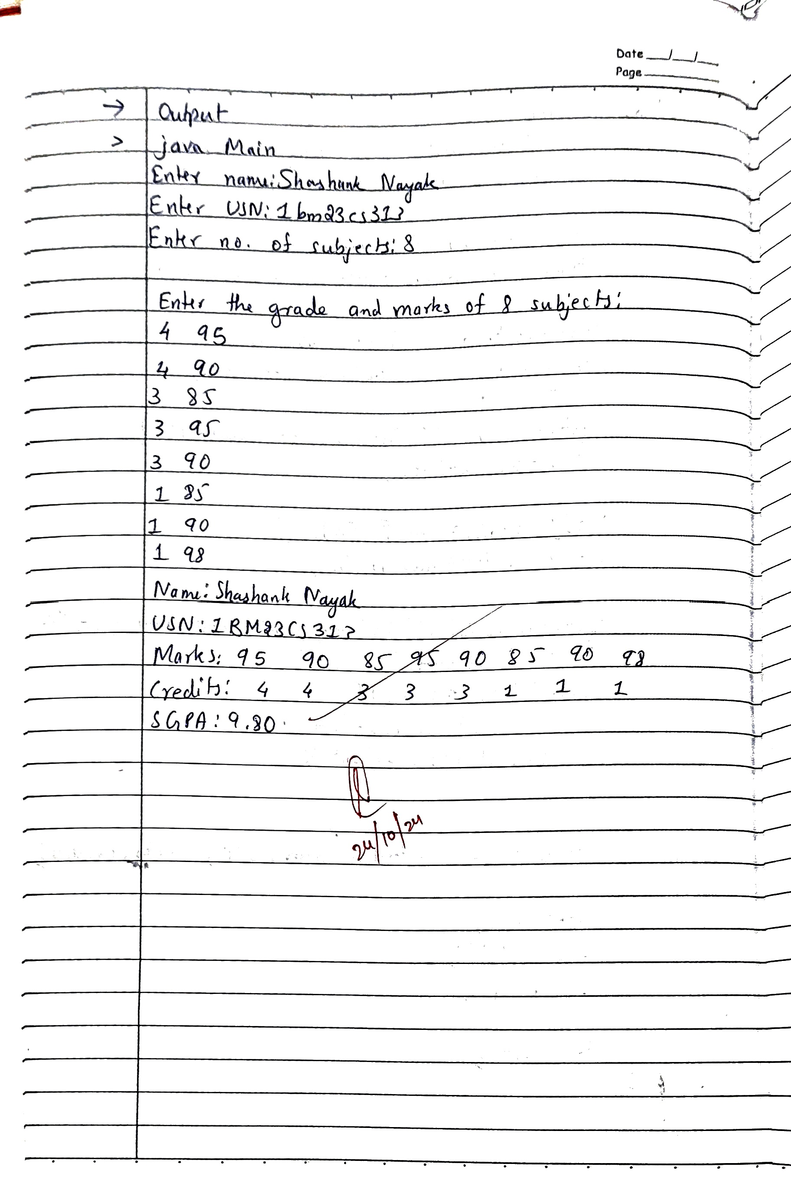

**Code:**

**import java.util.Scanner;**

**public class Student{**

**private String name;**

**private final String USN;**

**private int[] marks, credits, grades;**

**private double SGPA;**

**public Student(String name, String USN, int[] marks, int[] credits){**

**this.name=name;**

**this.USN=USN;**

**this.marks=marks;**

**this.credits=credits;**

**this.grades=new int[marks.length];**

**}**

**public void setGrades(){**

**for(int i=0;i<marks.length;i++){**

**if(marks[i]>=90 && marks[i]<=100){**

**grades[i]=10;**

**}**

**else if(marks[i]>=80 && marks[i]<90){**

**grades[i]=9;**

**}**

**else if(marks[i]>=70 && marks[i]<80){**

**grades[i]=8;**

**}**

**else if(marks[i]>=60 && marks[i]<70){**

**grades[i]=7;**

**}**

**else if(marks[i]>=50 && marks[i]<60){**

**grades[i]=6;**

**}**

**else**

**grades[i]=0;**

**}**

**}**

**public void setSGPA(){**

**int creditSum=0;**

**int sum=0;**

**for(int i=0;i<marks.length;i++){**

**creditSum+=credits[i];**

**sum+=grades[i]*credits[i];**

**}**

**this.SGPA=(float)sum/creditSum;**

**}**

**private String makeString(int[] array){**

**StringBuffer s=new StringBuffer("");**

**for(int ele: array)**

**s.append(ele+"\t");**

**return s.toString();**

**}**

**public void display(){**

**System.out.println(  
String.format("Name: %s\nUSN: %s\nMarks: %s\nCredits: %s\nSGPA: %.2f",name, USN, makeString(marks), makeString(credits), SGPA));**

**}**

**}**

**class Main{**

**public static void main(String args[]){**

**Scanner sc=new Scanner(System.in);**

**System.out.print("Enter name:");**

**String name=sc.nextLine();**

**System.out.print("Enter USN:");**

**String USN=sc.next().toUpperCase();**

**System.out.print("Enter no. of subjects:");**

**int n=sc.nextInt();**

**int[] marks=new int[n];**

**int[] credits=new int[n];**

**System.out.println("\nEnter the grade and marks of "+n+" subjects:");**

**for(int i=0;i<n;i++){**

**credits[i]=sc.nextInt();**

**marks[i]=sc.nextInt();**

**}**

**//Create Student**

**Student s=new Student(name, USN, marks, credits);**

**s.setGrades();**

**s.setSGPA();**

**s.display();**

**sc.close();**

**}**

**}**

**OUTPUT**

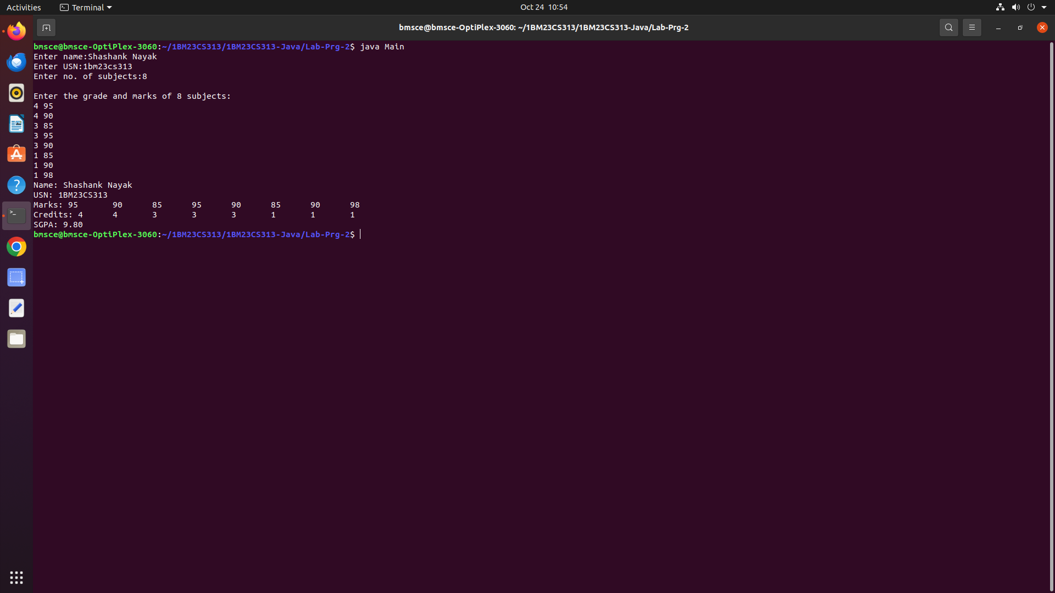

**LABORATORY PROGRAM - 3**

Create a class Book which contains four members: name, author, price, num_pages. Include a constructor to set the values for the members. Include methods to set and get the details of the objects. Include a toString( ) method that could display the complete details of the book. Develop a Java program to create n book objects.

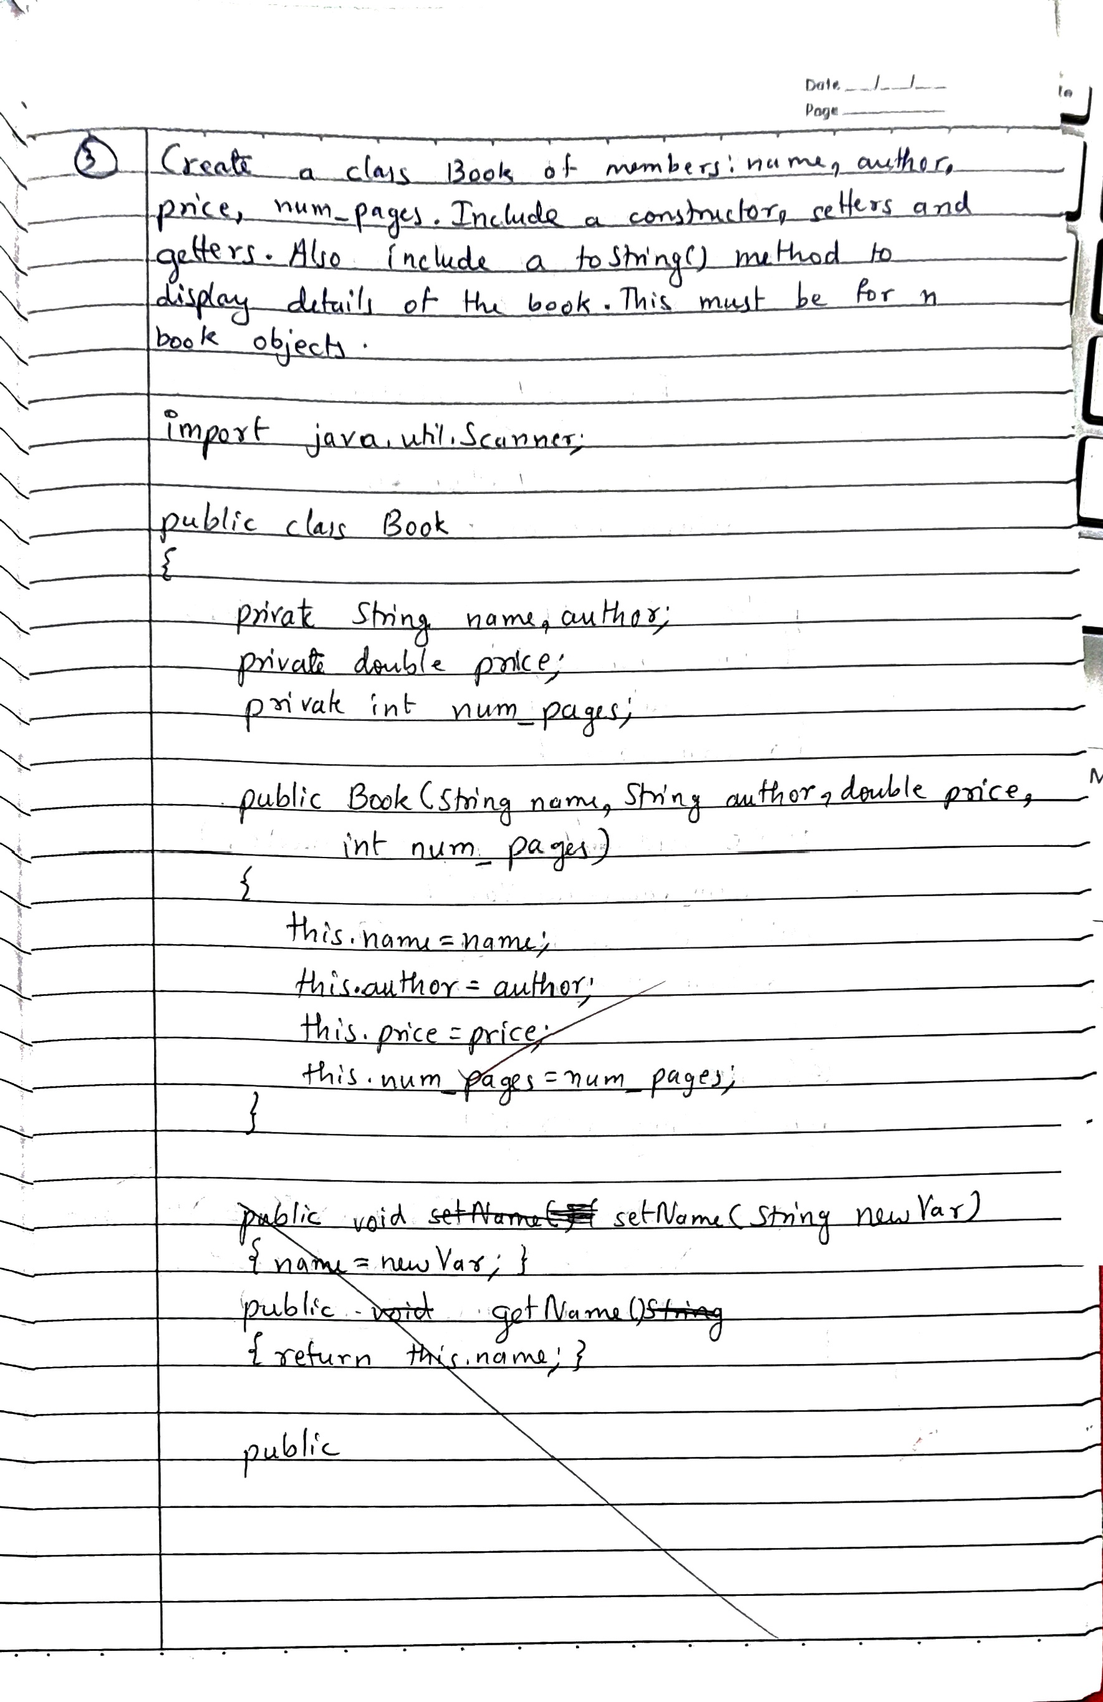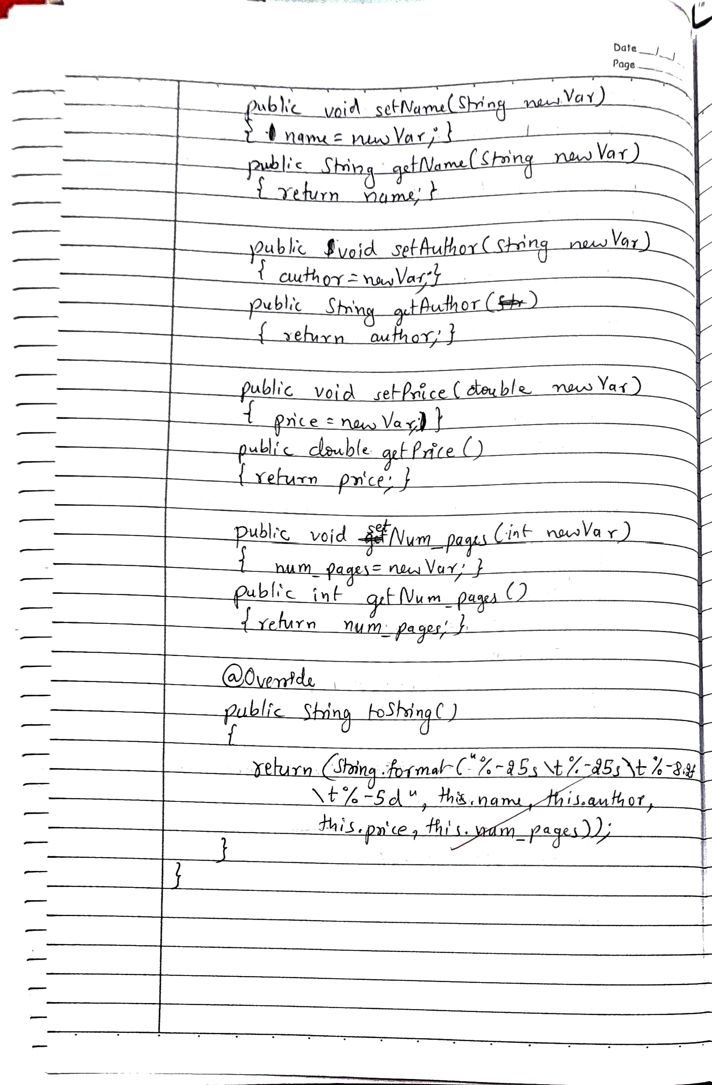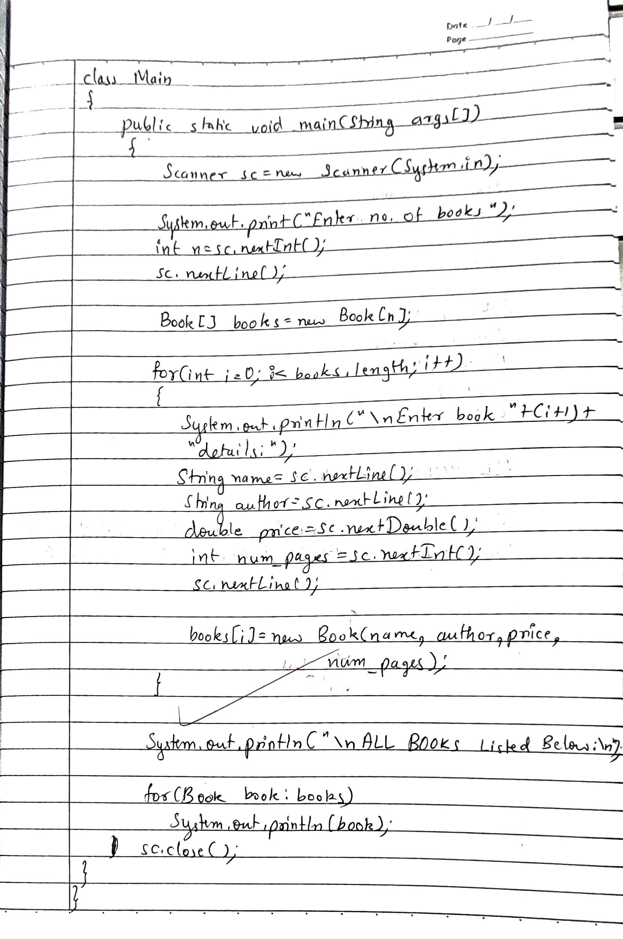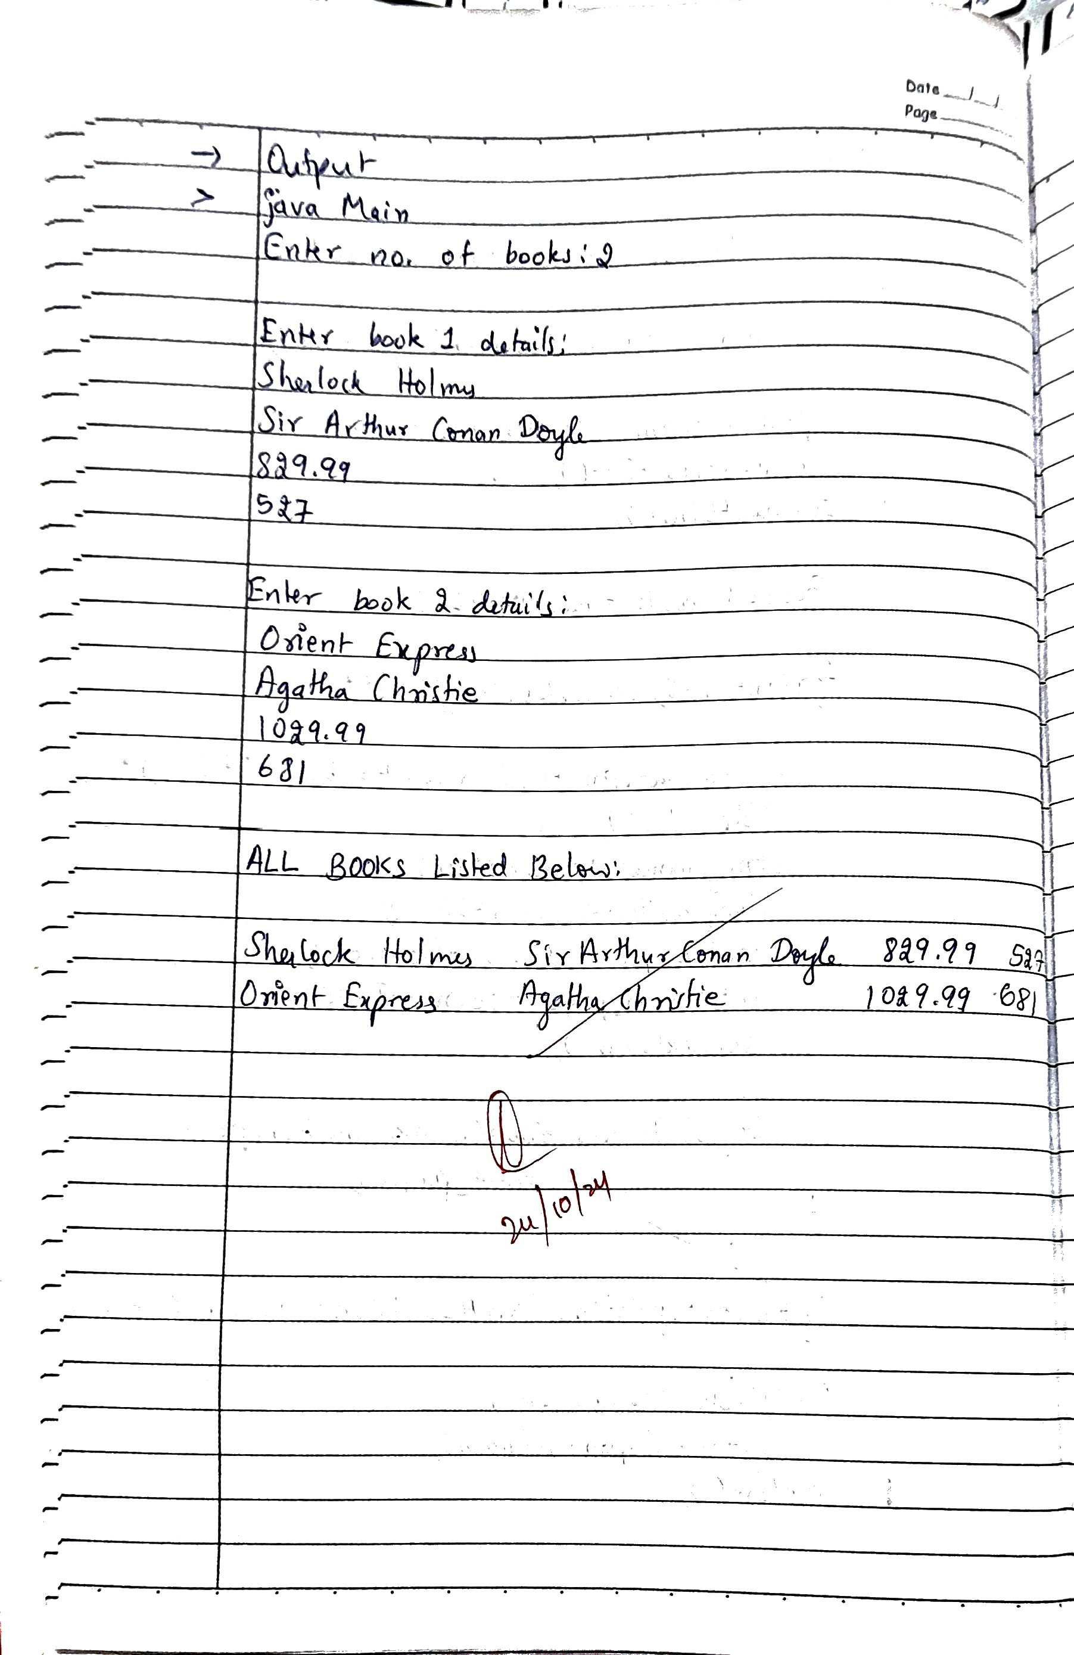

**Code:**

**import java.util.Scanner;**

**public class Book {**

**private String name;**

**private String author;**

**private double price;**

**private int num_pages;**

**public Book (String name, String author, double price, int num_pages) {**

**this.name=name;**

**this.author=author;**

**this.price=price;**

**this.num_pages=num_pages;**

**}**

**public void setName (String newVar) {**

**name = newVar;**

**}**

**public String getName () {**

**return name;**

**}**

**public void setAuthor (String newVar) {**

**author = newVar;**

**}**

**public String getAuthor () {**

**return author;**

**}**

**public void setPrice (double newVar) {**

**price = newVar;**

**}**

**public double getPrice () {**

**return price;**

**}**

**public void setNum_pages (int newVar) {**

**num_pages = newVar;**

**}**

**public int getNum_pages () {**

**return num_pages;**

**}**

**public String toString()**

**{**

**return(String.format("%-25s\t%-25s\t%-8.2f\t%-5d",this.name,this.author,this.price,this.num_pages));**

**}**

**}**

**class Main{**

**public static void main(String args[]){**

**Scanner sc=new Scanner(System.in);**

**System.out.print("Enter no. of books:");**

**int n=sc.nextInt();**

**sc.nextLine();**

**Book[] books=new Book[n];**

**for(int i=0;i<books.length;i++){**

**System.out.println("\nEnter book "+(i+1)+" details:");**

**String name=sc.nextLine();**

**String author=sc.nextLine();**

**double price=sc.nextDouble();**

**int num_pages=sc.nextInt();**

**sc.nextLine();**

**books[i]=new Book(name, author, price, num_pages);**

**}**

**System.out.println("\nALL BOOKS Listed Below:\n");**

**for(Book book:books){**

**System.out.println(book);**

**}**

**sc.close();**

**}**

**}**

**OUTPUT**

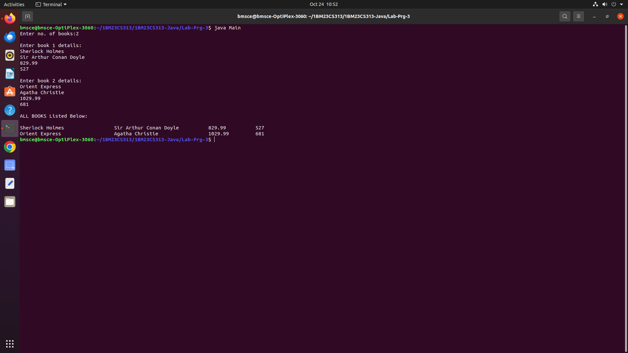

**LABORATORY PROGRAM - 4**

Develop a Java program to create an abstract class named Shape that contains two integers and an empty method named printArea( ). Provide three classes named Rectangle, Triangle and Circle such that each one of the classes extends the class Shape. Each one of the classes contain only the method printArea( ) that prints the area of the given shape.

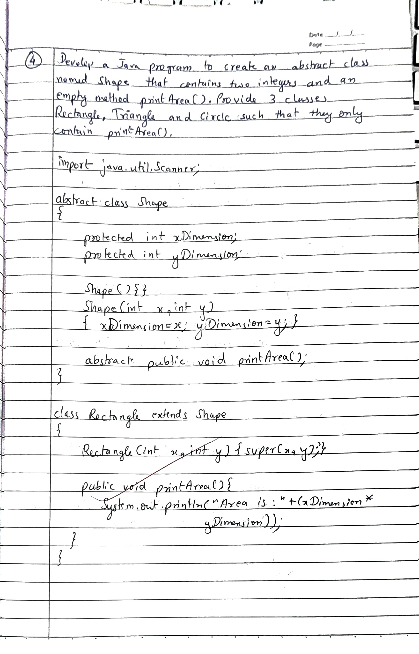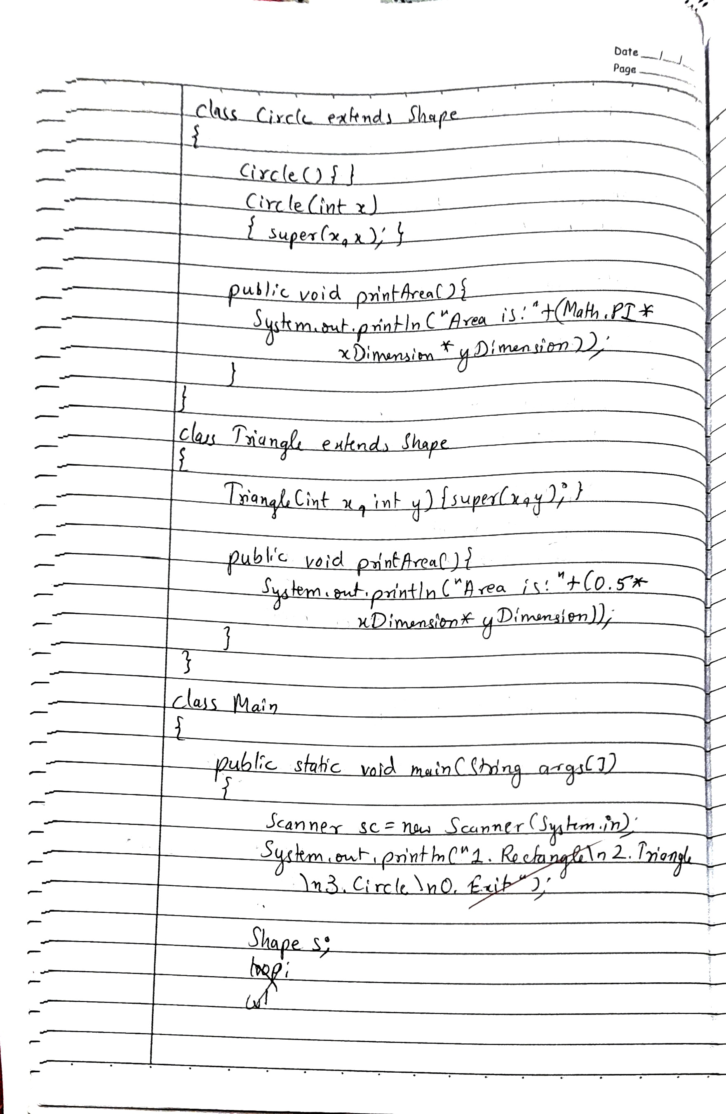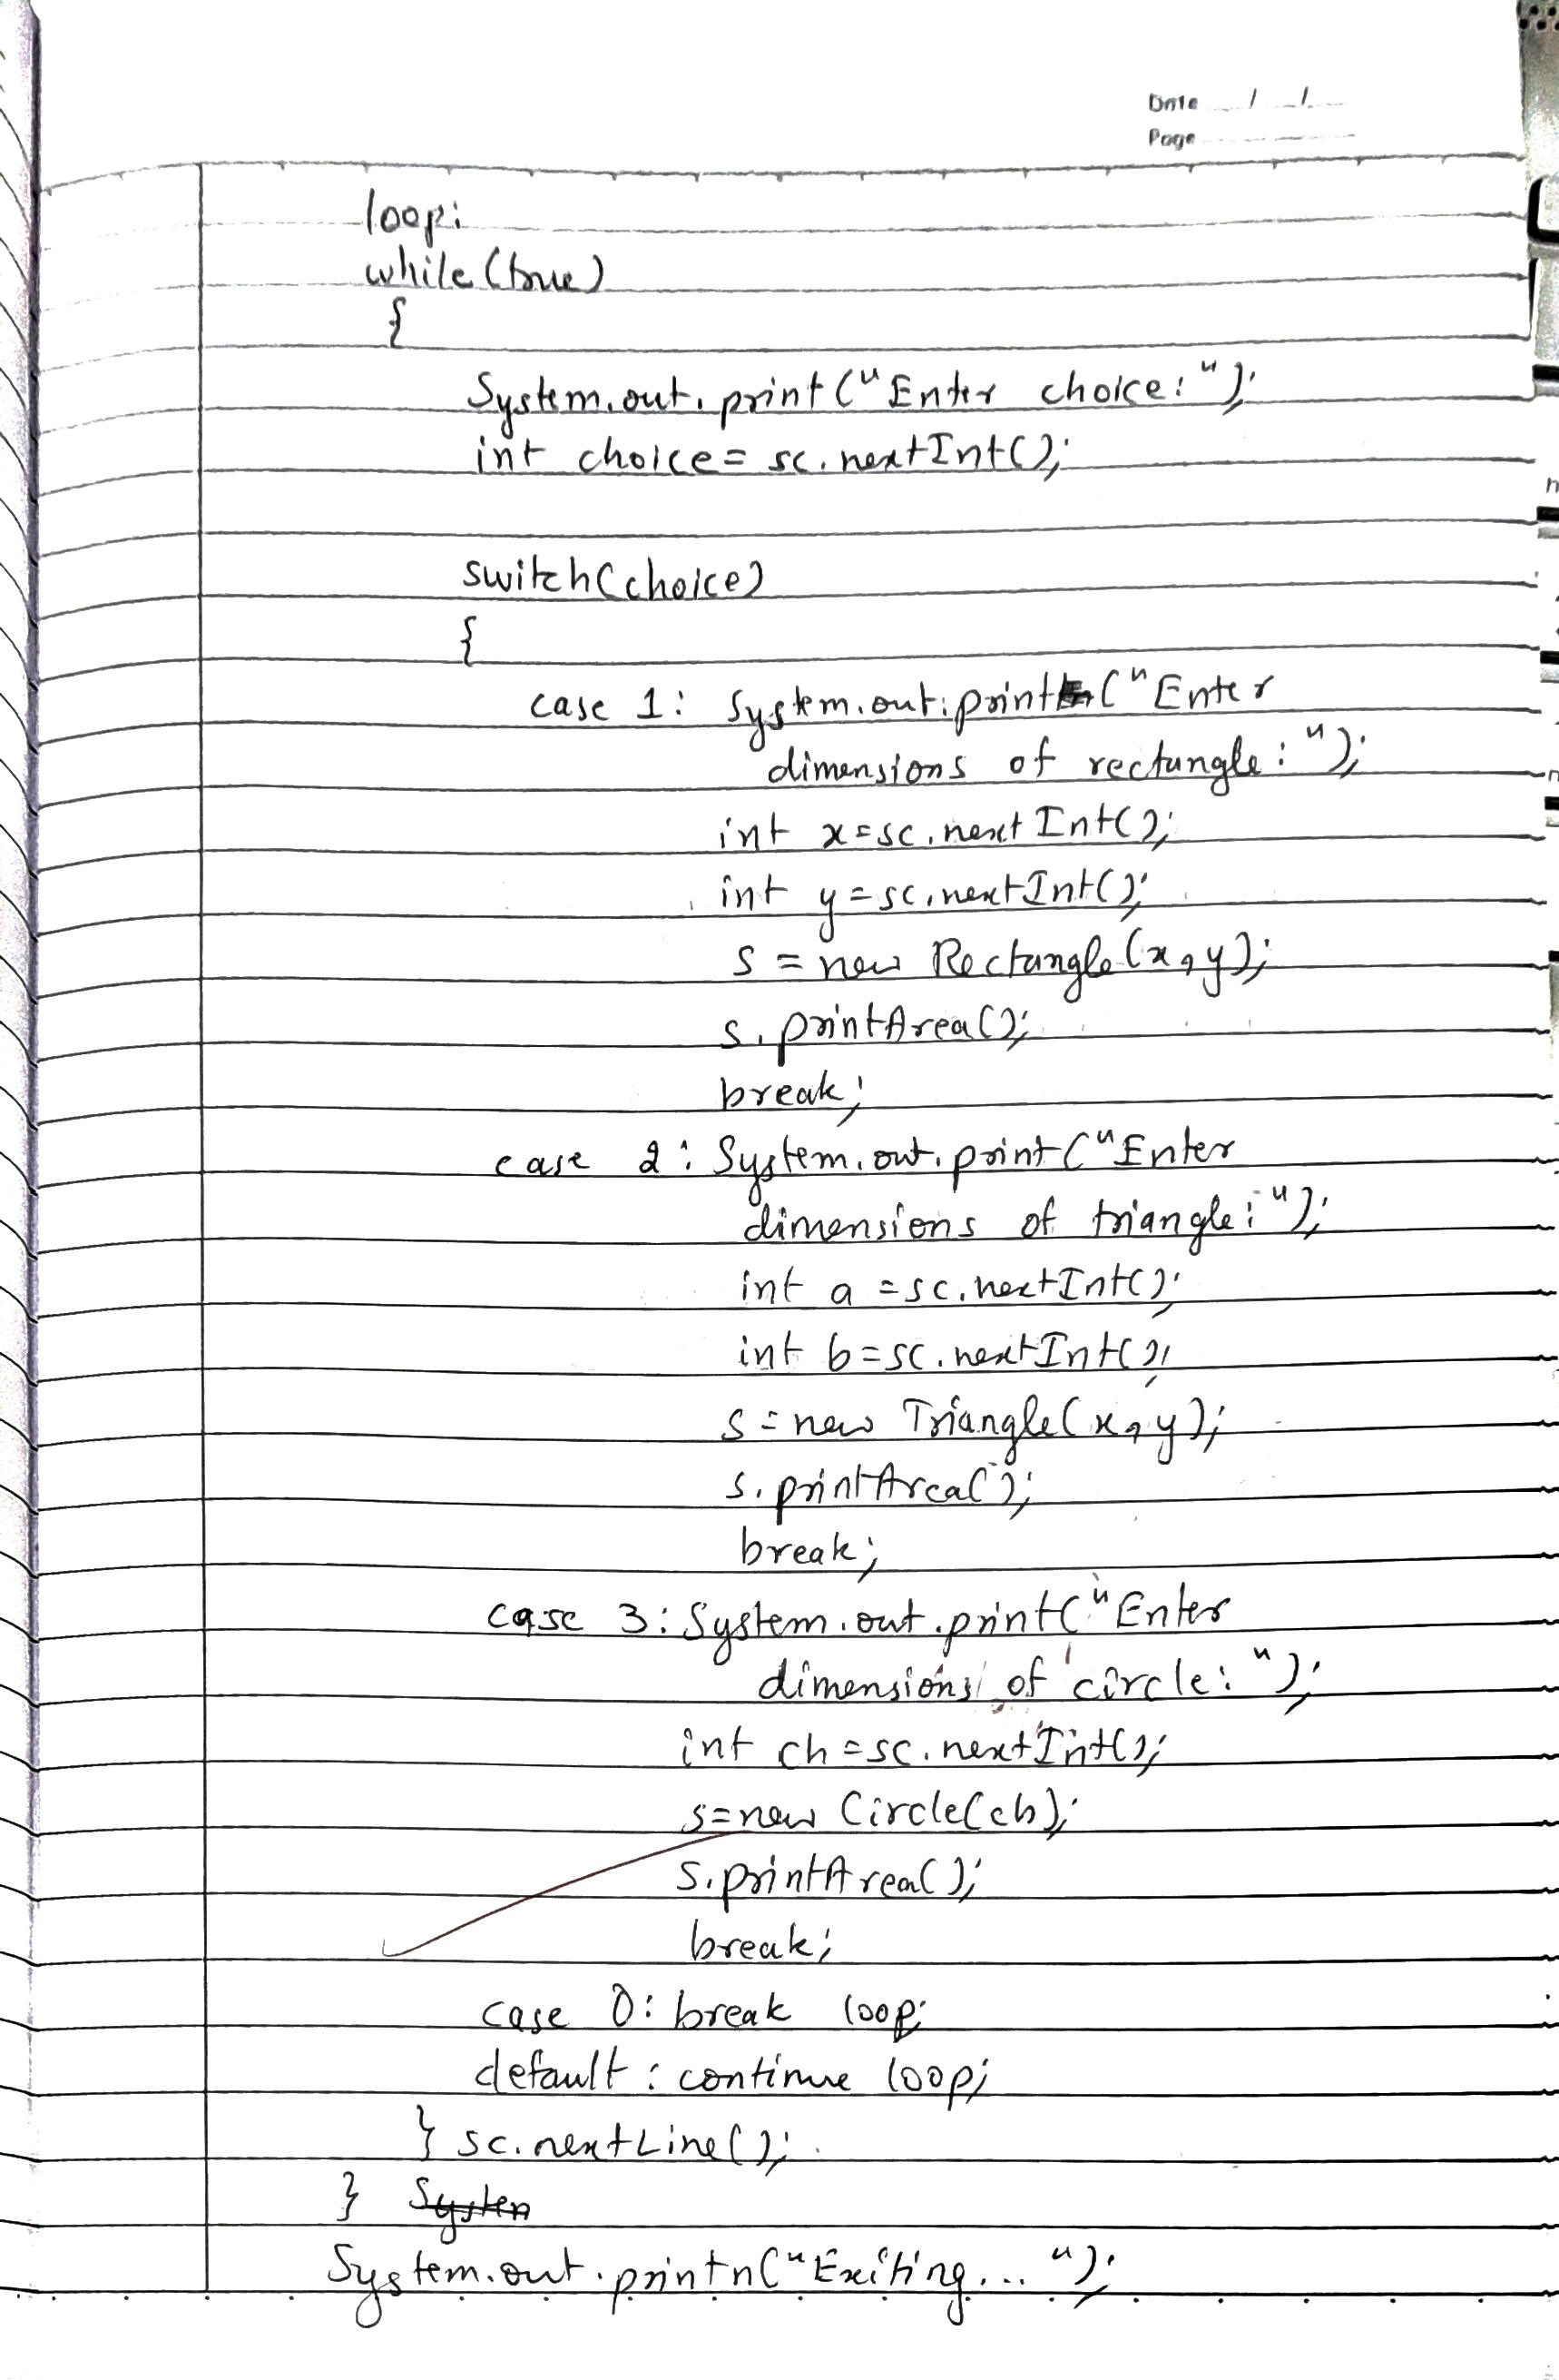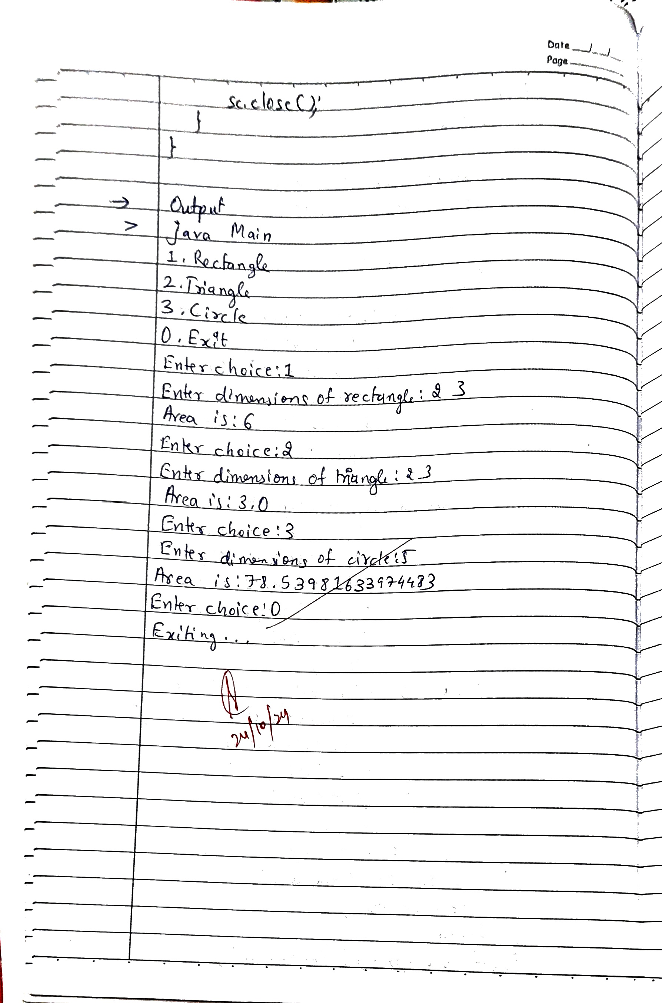

**Code:**

**import java.util.Scanner;**

**abstract class Shape**

**{**

**protected int xDimension;**

**protected int yDimension;**

**Shape(){}**

**Shape(int x, int y)**

**{**

**xDimension=x;**

**yDimension=y;**

**}**

**abstract public void printArea();**

**}**

**class Rectangle extends Shape**

**{**

**Rectangle(int x, int y){super(x,y);}**

**public void printArea(){System.out.println("Area is:"+(xDimension*yDimension));}**

**}**

**class Circle extends Shape**

**{**

**Circle(){}**

**Circle(int x){**

**super(x,x);**

**}**

**public void printArea(){System.out.println("Area is:"+(Math.PI*xDimension*yDimension));}**

**}**

**class Triangle extends Shape**

**{**

**Triangle(int x, int y){super(x,y);}**

**public void printArea(){System.out.println("Area is:"+(0.5*xDimension*yDimension));}**

**}**

**class Main**

**{**

**public static void main(String args[])**

**{**

**Scanner sc=new Scanner(System.in);**

**System.out.println("1. Rectangle\n2. Triangle\n3. Circle\n0. Exit");**

**Shape s;**

**loop:**

**while(true)**

**{**

**System.out.print("Enter choice:");**

**int choice=sc.nextInt();**

**switch(choice)**

**{**

**case 1: System.out.print("Enter dimensions of rectangle:");**

**int x=sc.nextInt();**

**int y=sc.nextInt();**

**s=new Rectangle(x,y);**

**s.printArea();**

**break;**

**case 2: System.out.print("Enter dimensions of triangle:");**

**int a=sc.nextInt();**

**int b=sc.nextInt();**

**s=new Triangle(a,b);**

**s.printArea();**

**break;**

**case 3: System.out.print("Enter dimensions of circle:");**

**int ch=sc.nextInt();**

**s=new Circle(ch);**

**s.printArea();**

**break;**

**case 0: break loop;**

**default: continue loop;**

**}**

**sc.nextLine();**

**}**

**System.out.println("Exiting...");**

**sc.close();**

**}**

**}**

**OUTPUT**

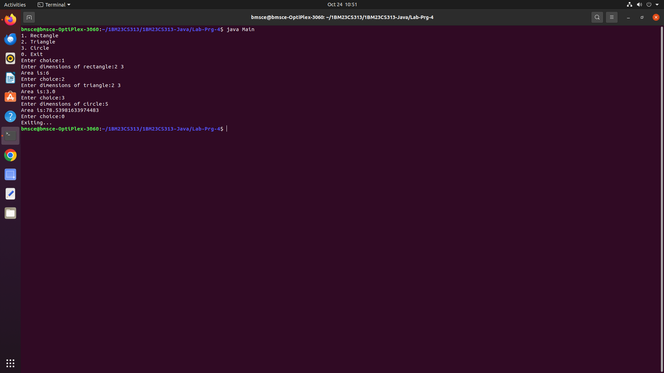

**LABORATORY PROGRAM - 5**

Develop a Java program to create a class Bank that maintains two kinds of account for its customers, one called savings account and the other current account. The savings account provides compound interest and withdrawal facilities but no cheque book facility. The current account provides cheque book facility but no interest. Current account holders should also maintain a minimum balance and if the balance falls below this level, a service charge is imposed. Create a class Account that stores customer name, account number and type of account. From this derive the classes Cur-acct and Sav-acct to make them more specific to their requirements. Include the necessary methods in order to achieve the following tasks:

a) Accept deposit from customer and update the balance.

b) Display the balance.

c) Compute and deposit interest.

d) Permit withdrawal and update the balance.

Check for the minimum balance, impose penalty if necessary and update the balance.

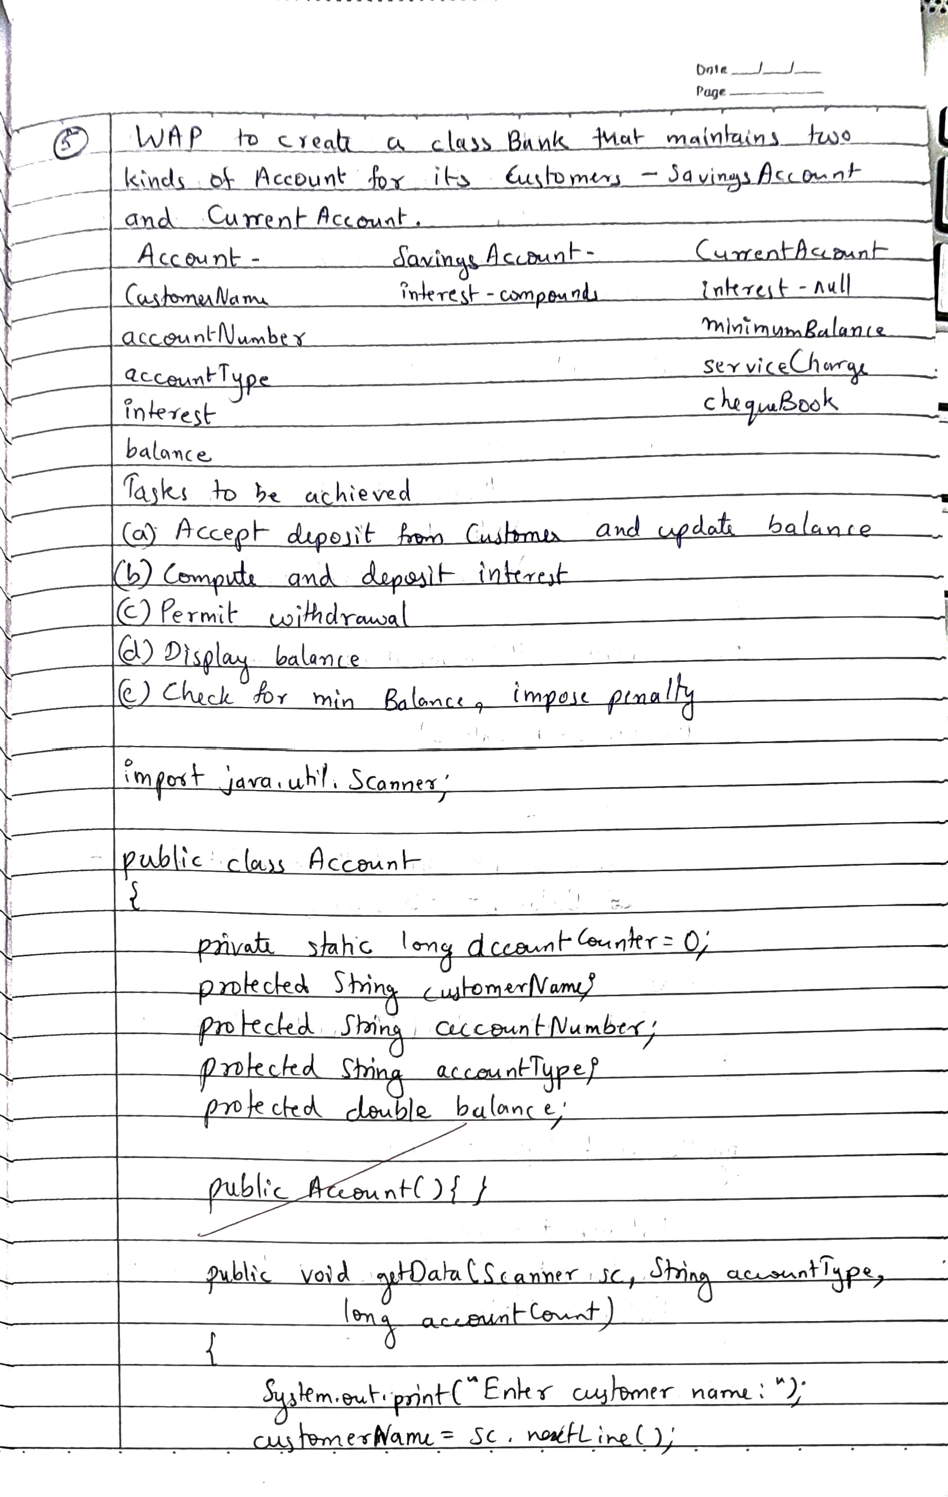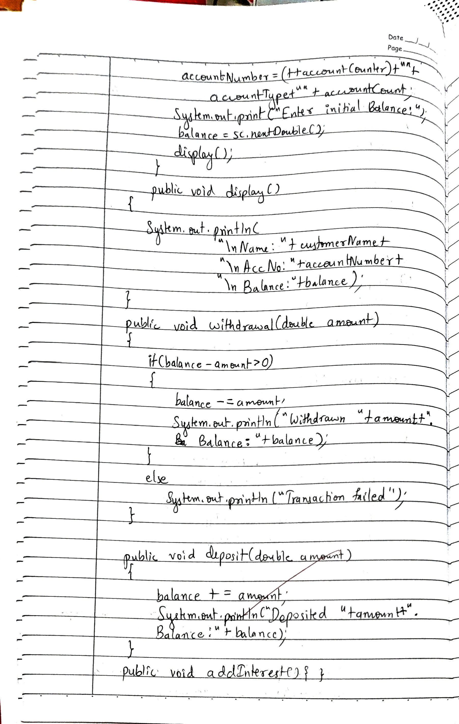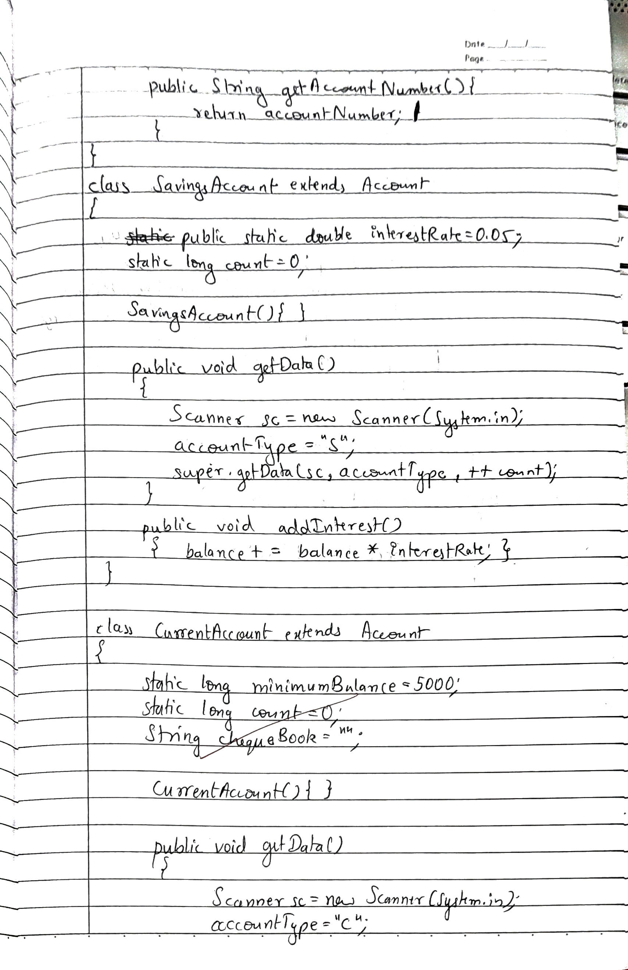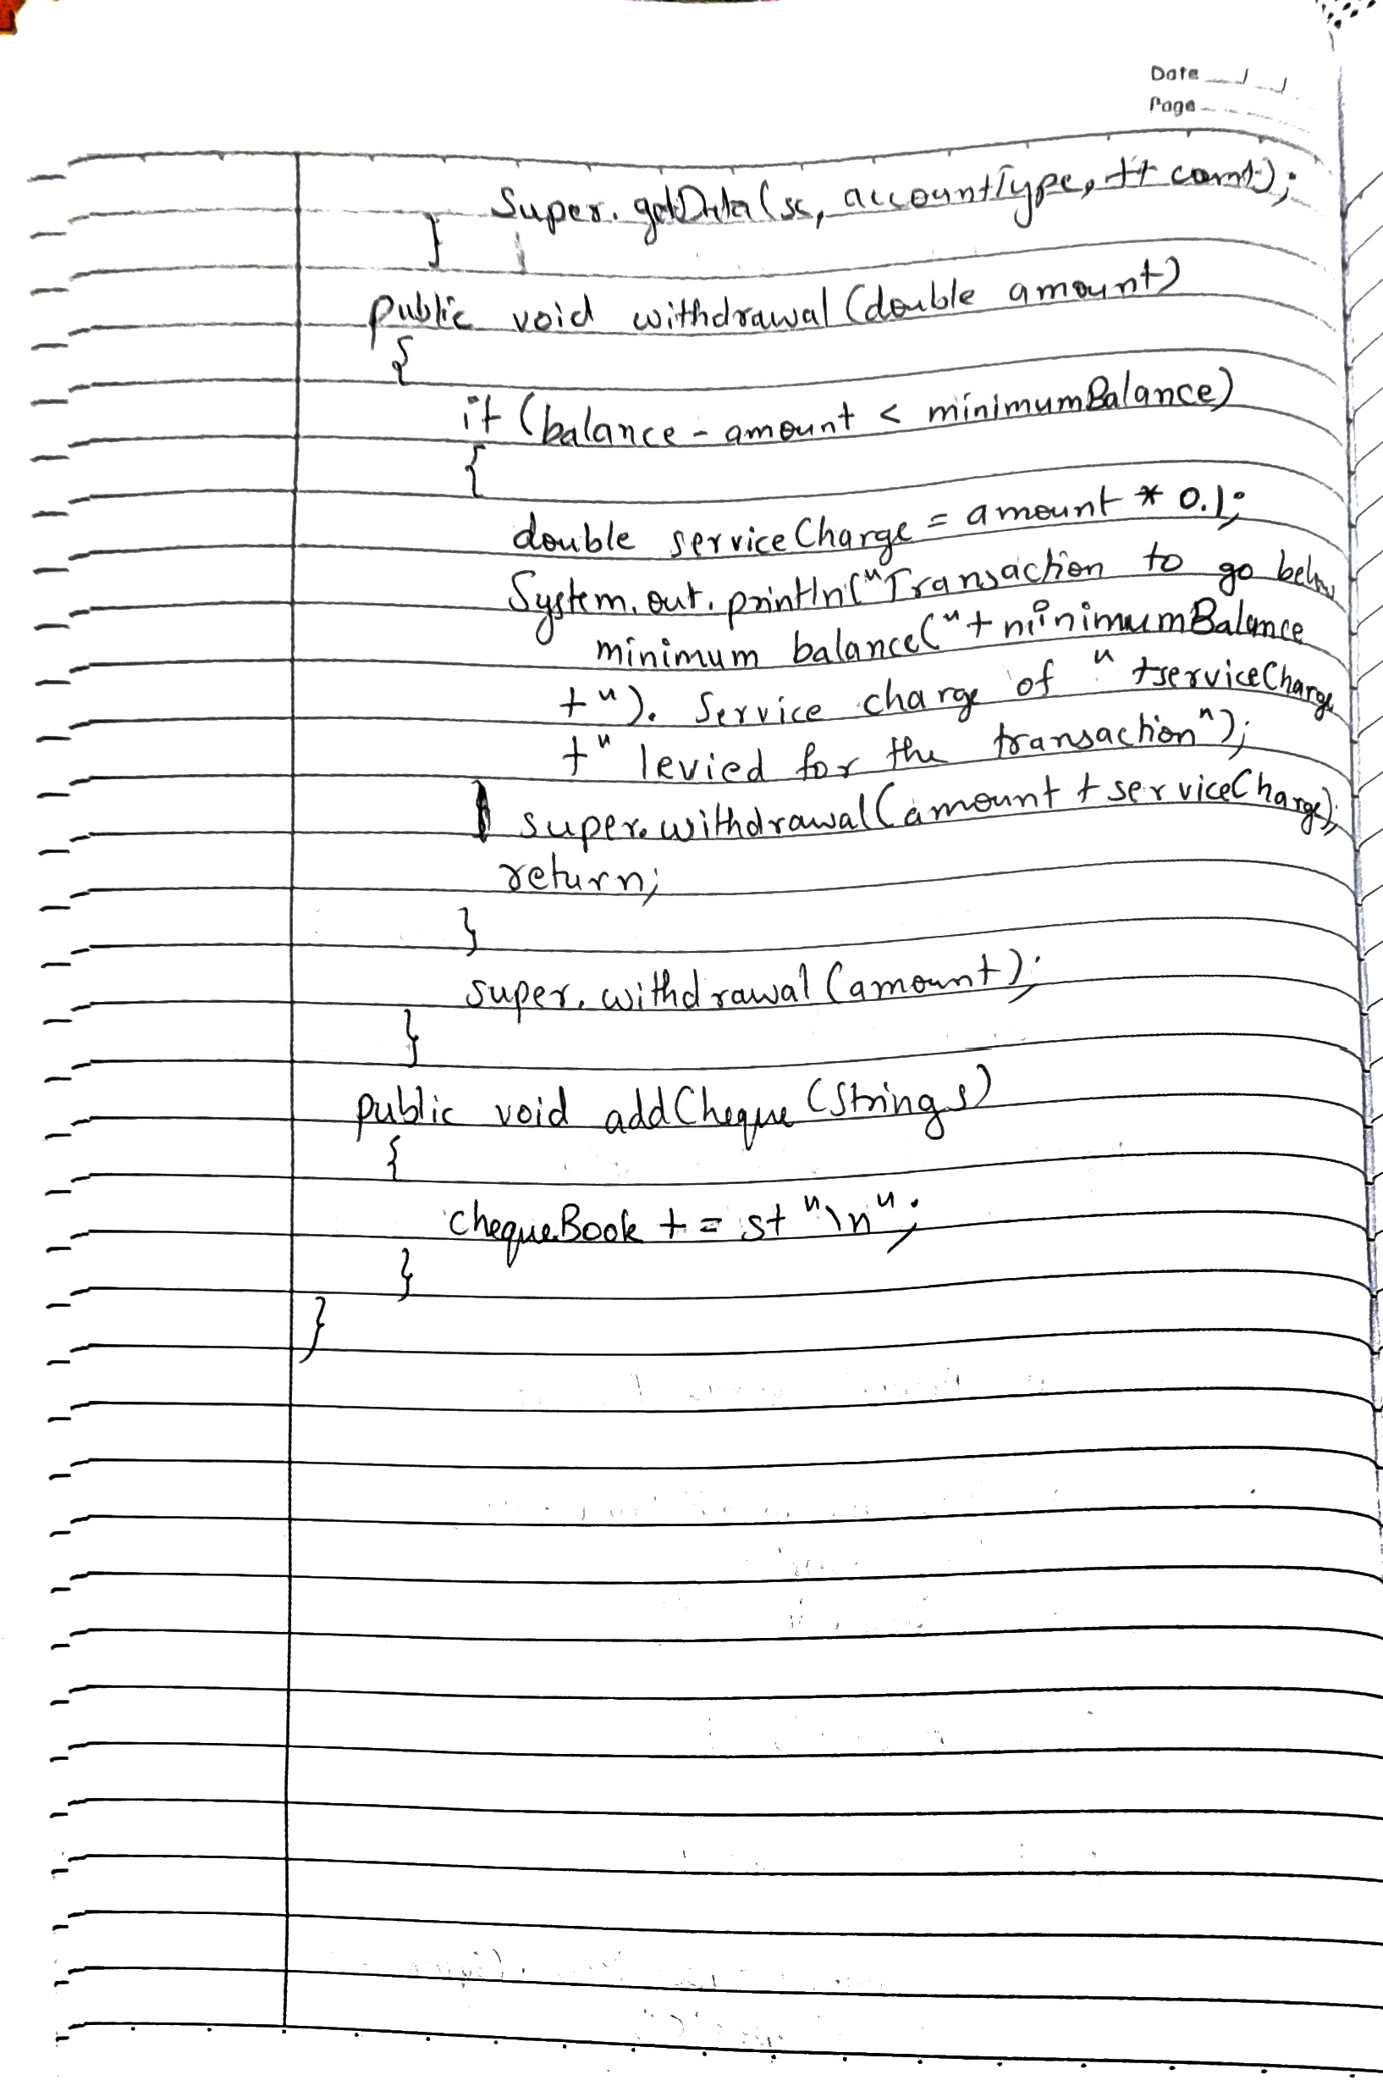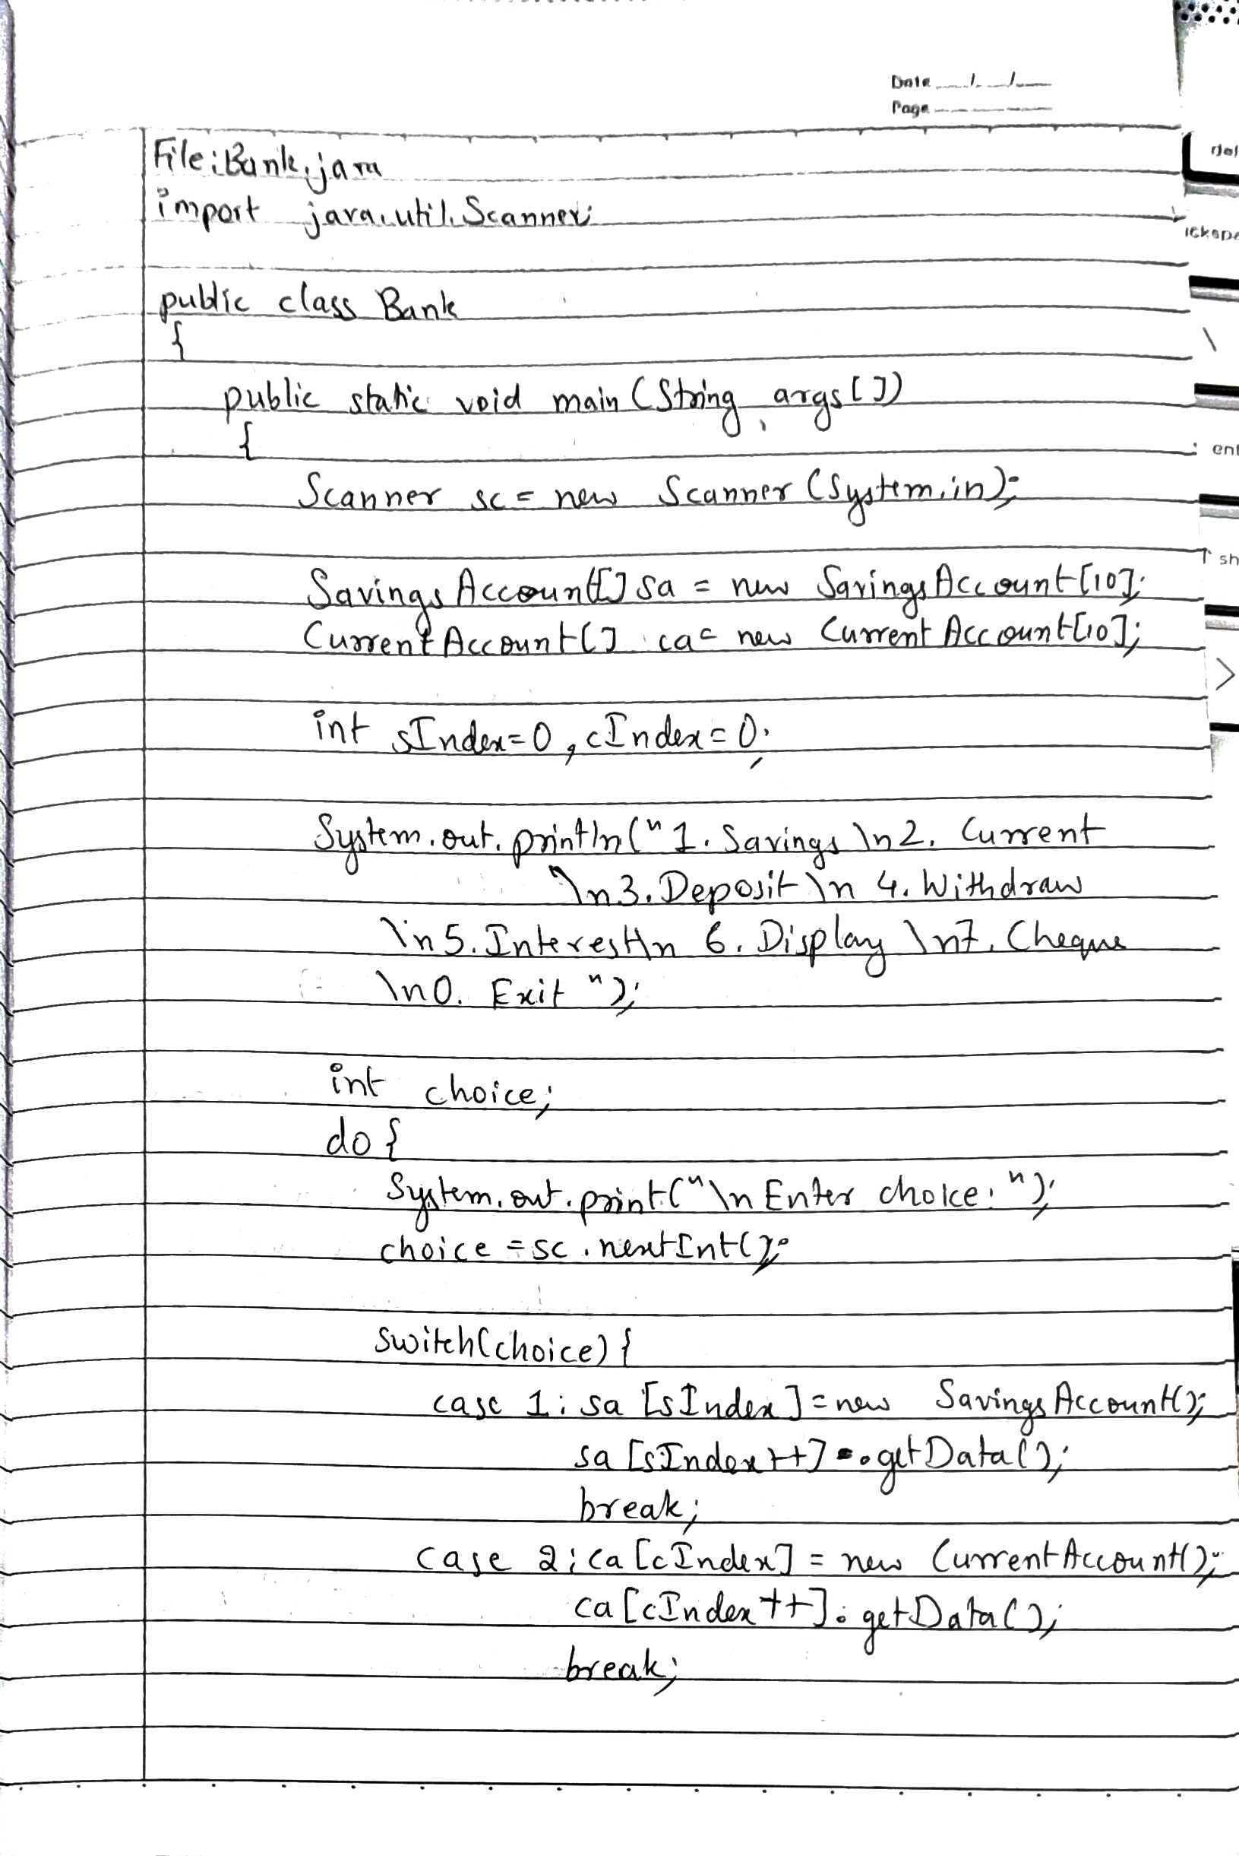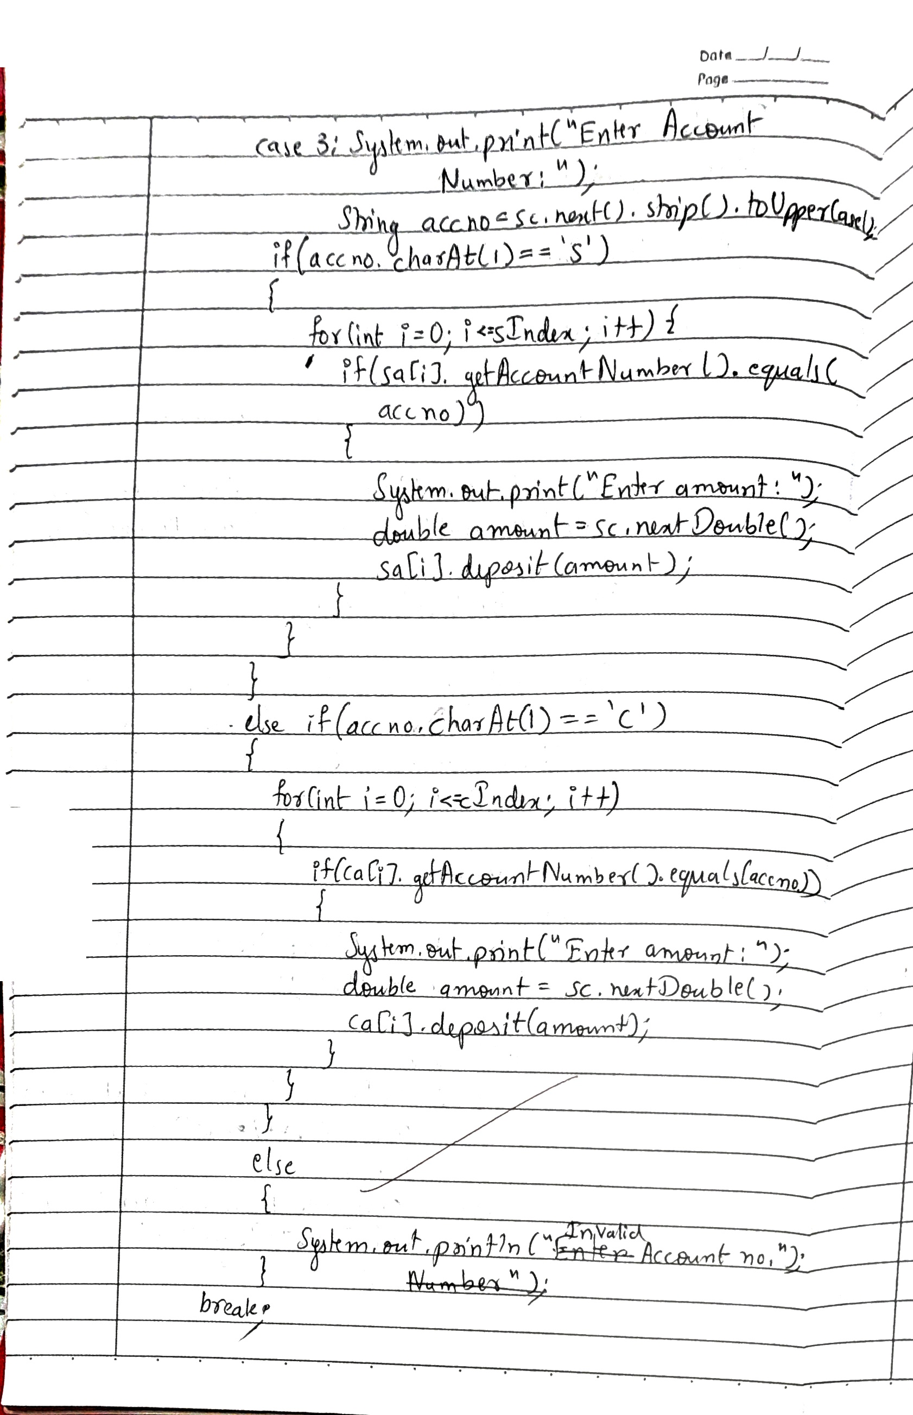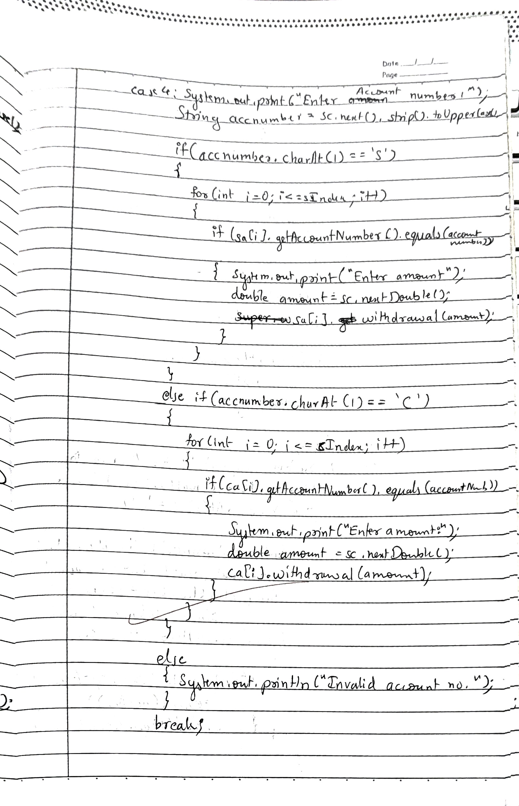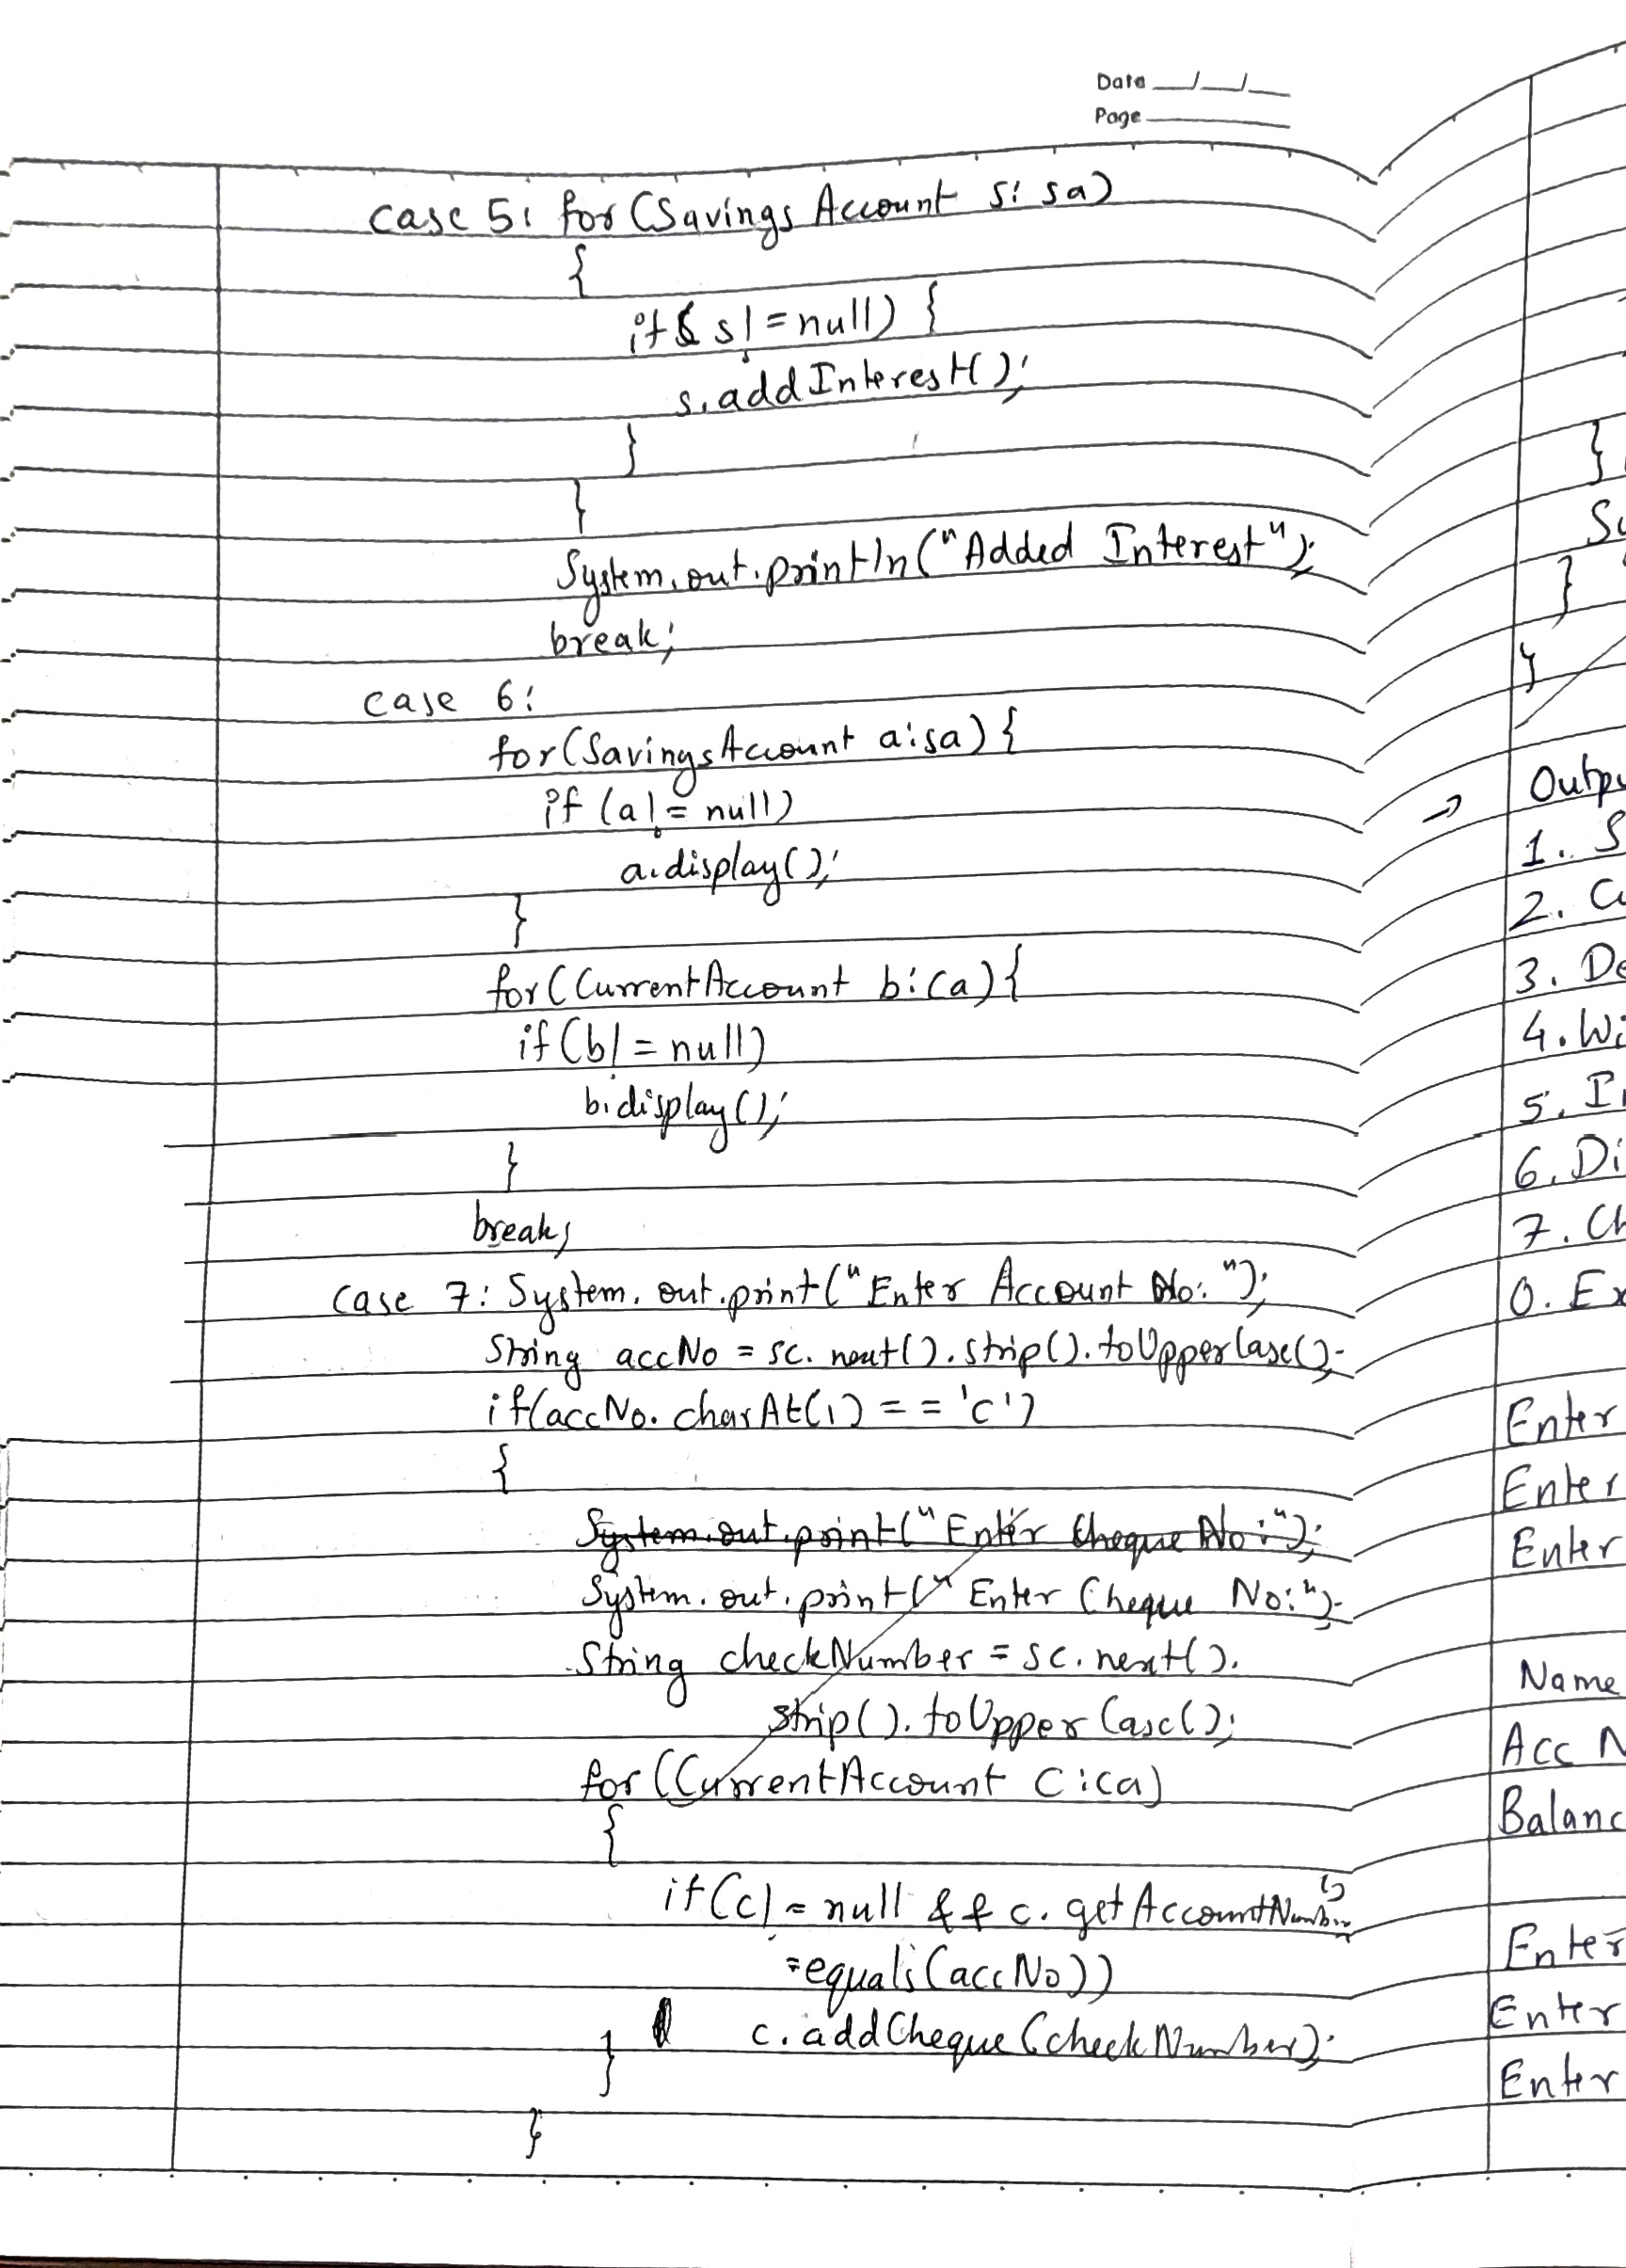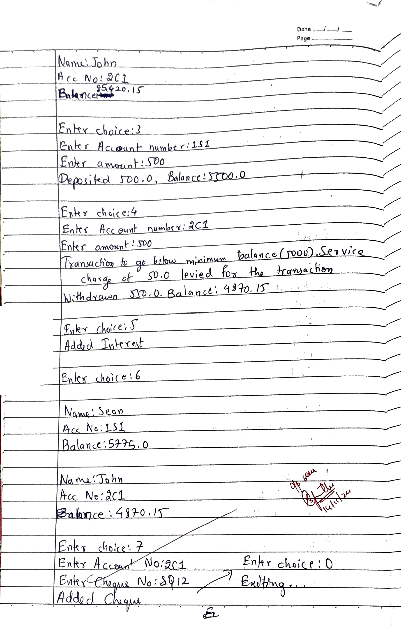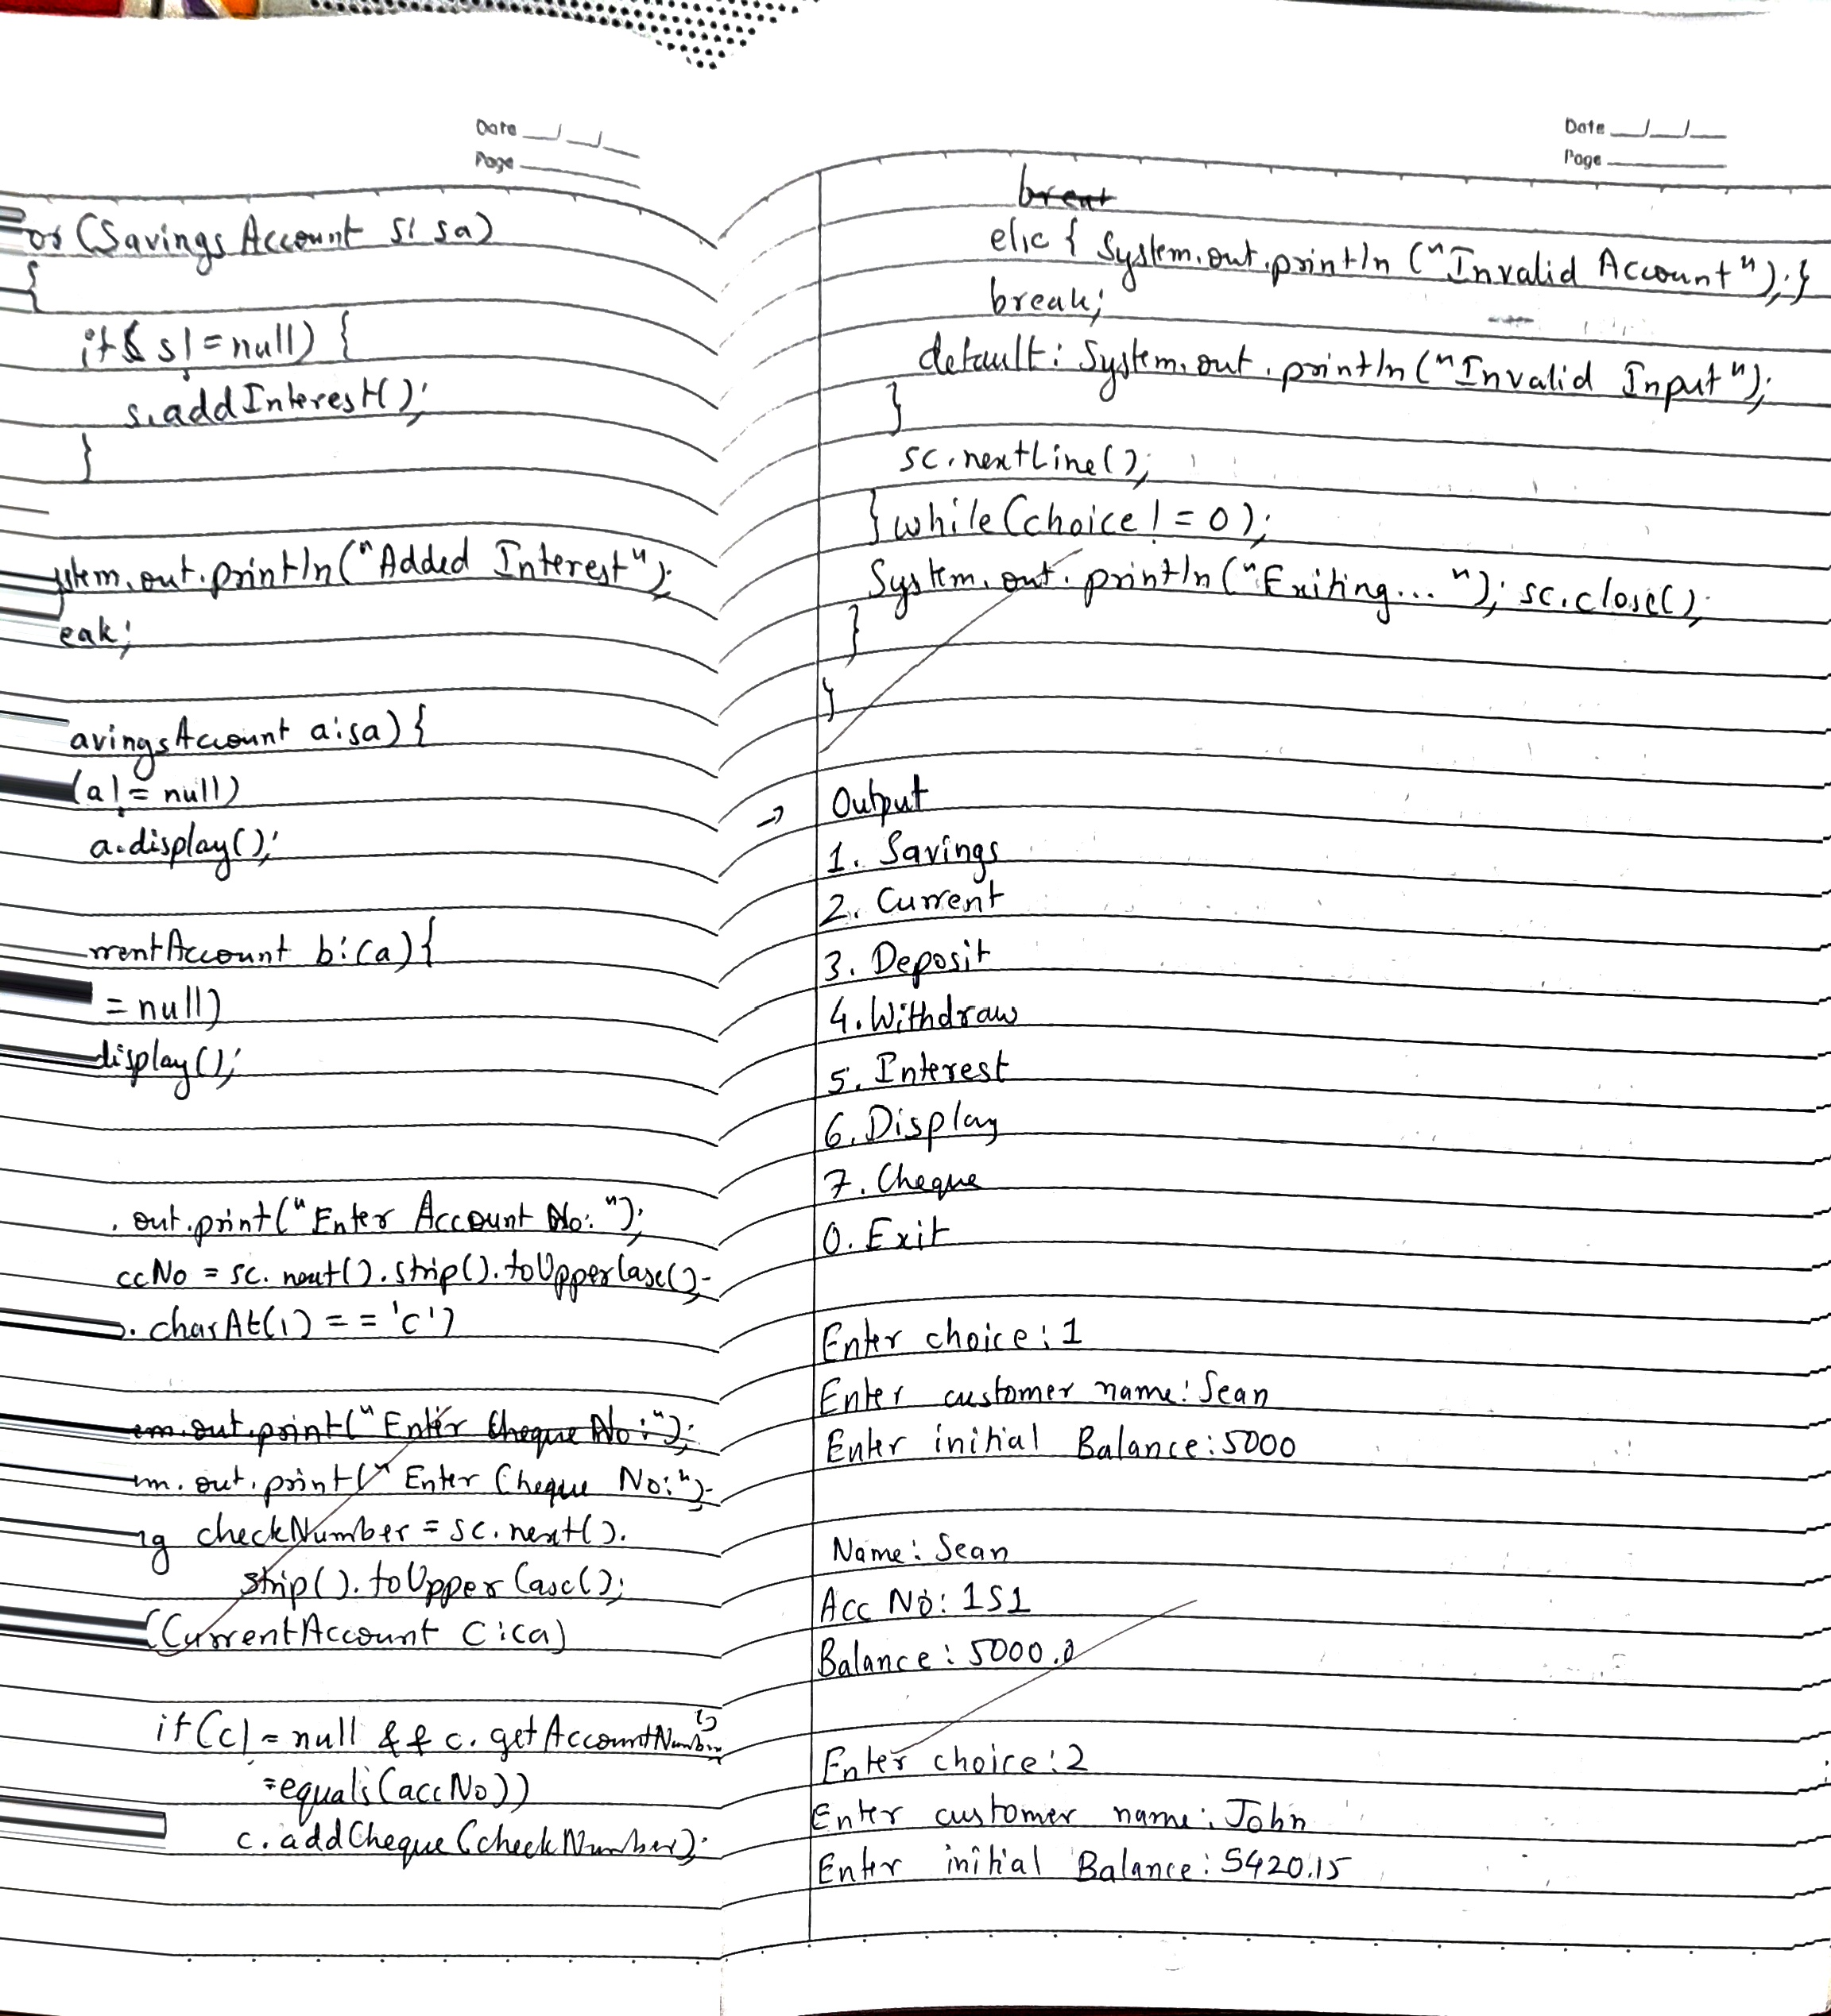

**Code:**

**// Account.java**

**import java.util.Scanner;**

**public class Account**

**{**

**private static long accountCounter=0;**

**protected String customerName;**

**protected String accountNumber;**

**protected String accountType;**

**protected double balance;**

**public Account(){**

**}**

**public void getData(Scanner sc, String accountType, long accountCount)**

**{**

**System.out.print("Enter customer name:");**

**customerName = sc.nextLine();**

**accountNumber = (++accountCounter)+""+accountType+""+accountCount;**

**System.out.print("Enter initial Balance:");**

**balance = sc.nextDouble();**

**display();**

**}**

**public void display()**

**{**

**System.out.println(**

**"\nName:"+customerName+**

**"\nAcc No:"+accountNumber+**

**"\nBalance:"+balance);**

**}**

**public void withdrawal(double amount)**

**{**

**if(balance-amount>0)**

**{**

**balance -= amount;**

**System.out.println("Withdrawn "+amount+**

**". Balance:"+balance);**

**}**

**else**

**{**

**System.out.println("Transaction failed.");**

**}**

**}**

**public void deposit(double amount)**

**{**

**balance += amount;**

**System.out.println("Deposited "+amount+**

**". Balance:"+balance);**

**}**

**public void getBalance(){**

**System.out.println("Balance:"+balance);**

**}**

**public String getAccountNumber(){return accountNumber;}**

**public void addInterest(){}**

**}**

**class SavingsAccount extends Account**

**{**

**static public double interestRate=0.05;**

**static long count=0;**

**SavingsAccount(){**

**}**

**public void getData(){**

**Scanner sc = new Scanner(System.in);**

**accountType = "S";**

**super.getData(sc, accountType,++count);**

**}**

**public void addInterest(){**

**balance += balance*interestRate;**

**}**

**}**

**class CurrentAccount extends Account**

**{**

**static long minimumBalance = 5000;**

**static long count=0;**

**String chequeBook = "";**

**CurrentAccount(){**

**}**

**public void getData(){**

**Scanner sc = new Scanner(System.in);**

**accountType = "C";**

**super.getData(sc,accountType,++count);**

**}**

**public void withdrawal(double amount){**

**if (balance-amount < minimumBalance)**

**{**

**double serviceCharge = amount * 0.1;**

**System.out.println("Transaction to go below minimum balance("+**

**minimumBalance+"). Service charge of "+**

**serviceCharge+" levied for the transaction");**

**super.withdrawal(amount+serviceCharge);**

**return;**

**}**

**super.withdrawal(amount);**

**}**

**public void addCheque(String s)**

**{**

**chequeBook = chequeBook+s+"\n";**

**}**

**}**

**// Bank.java**

**import java.util.Scanner;**

**public class Bank**

**{**

**public static void main(String args[])**

**{**

**Scanner sc = new Scanner(System.in);**

**SavingsAccount[] sa = new SavingsAccount[10];**

**CurrentAccount[] ca = new CurrentAccount[10];**

**int sIndex=0, cIndex=0;**

**System.out.println("1. Savings\n2. Current\n3. Deposit\n4. Withdraw\n5. Interest\n6. Display\n7. Cheque\n0. Exit");**

**int choice;**

**do**

**{**

**System.out.print("\nEnter choice:");**

**choice = sc.nextInt();**

**switch(choice)**

**{**

**case 1 :sa[sIndex]=new SavingsAccount();**

**sa[sIndex++].getData();**

**break;**

**case 2 :ca[cIndex]=new CurrentAccount();**

**ca[cIndex++].getData();**

**break;**

**case 3 :System.out.print("Enter Account number:");**

**String accno = sc.next().strip().toUpperCase();**

**if(accno.charAt(1)=='S')**

**{**

**for(int i=0;i<sIndex;i++)**

**{**

**if(sa[i].getAccountNumber().equals(accno))**

**{**

**System.out.print("Enter amount:");**

**double amount = sc.nextDouble();**

**sa[i].deposit(amount);**

**}**

**}**

**}**

**else if(accno.charAt(1)=='C')**

**{**

**for(int i=0;i<cIndex;i++)**

**{**

**if(ca[i].getAccountNumber().equals(accno))**

**{**

**System.out.print("Enter amount:");**

**double amount = sc.nextDouble();**

**ca[i].deposit(amount);**

**}**

**}**

**}**

**else**

**{**

**System.out.println("Invalid account no.");**

**}**

**break;**

**case 4 :System.out.print("Enter Account number:");**

**String accnumber = sc.next().strip().toUpperCase();**

**if(accnumber.charAt(1)=='S')**

**{**

**for(int i=0;i<sIndex;i++)**

**{**

**if(sa[i].getAccountNumber().equals(accnumber))**

**{**

**System.out.print("Enter amount:");**

**double amount = sc.nextDouble();**

**sa[i].withdrawal(amount);**

**}**

**}**

**}**

**else if(accnumber.charAt(1)=='C')**

**{**

**for(int i=0;i<cIndex;i++)**

**{**

**if(ca[i].getAccountNumber().equals(accnumber))**

**{**

**System.out.print("Enter amount:");**

**double amount = sc.nextDouble();**

**ca[i].withdrawal(amount);**

**}**

**}**

**}**

**else**

**{**

**System.out.println("Invalid account no.");**

**}**

**break;**

**case 5 :for(SavingsAccount s: sa)**

**{**

**if(s!=null)**

**{**

**s.addInterest();**

**}**

**}**

**System.out.println("Added Interest");**

**break;**

**case 6:**

**// Display Savings Accounts**

**for (SavingsAccount a : sa) {**

**if (a != null) { // Check if the account is initialized**

**a.display();**

**}**

**}**

**// Display Current Accounts**

**for (CurrentAccount b : ca) {**

**if (b != null) { // Check if the account is initialized**

**b.display();**

**}**

**}**

**break;**

**case 7: System.out.print("Enter Account No:");**

**String accNo = sc.next().strip().toUpperCase();**

**if(accNo.charAt(1)=='C')**

**{**

**System.out.print("Enter Cheque No:");**

**String checkNumber = sc.next().strip().toUpperCase();**

**for(CurrentAccount c: ca)**

**{**

**if(c!=null && c.getAccountNumber().equals(accNo))**

**c.addCheque(checkNumber);**

**}**

**System.out.println("Added Cheque");**

**}**

**else**

**{**

**System.out.println("Invalid Account");**

**}**

**break;**

**case 0: break;**

**default:System.out.println("Invalid Input");**

**}**

**sc.nextLine();**

**}while(choice!=0);**

**System.out.println("Exiting...");**

**sc.close();**

**}**

**}**

**OUTPUT**

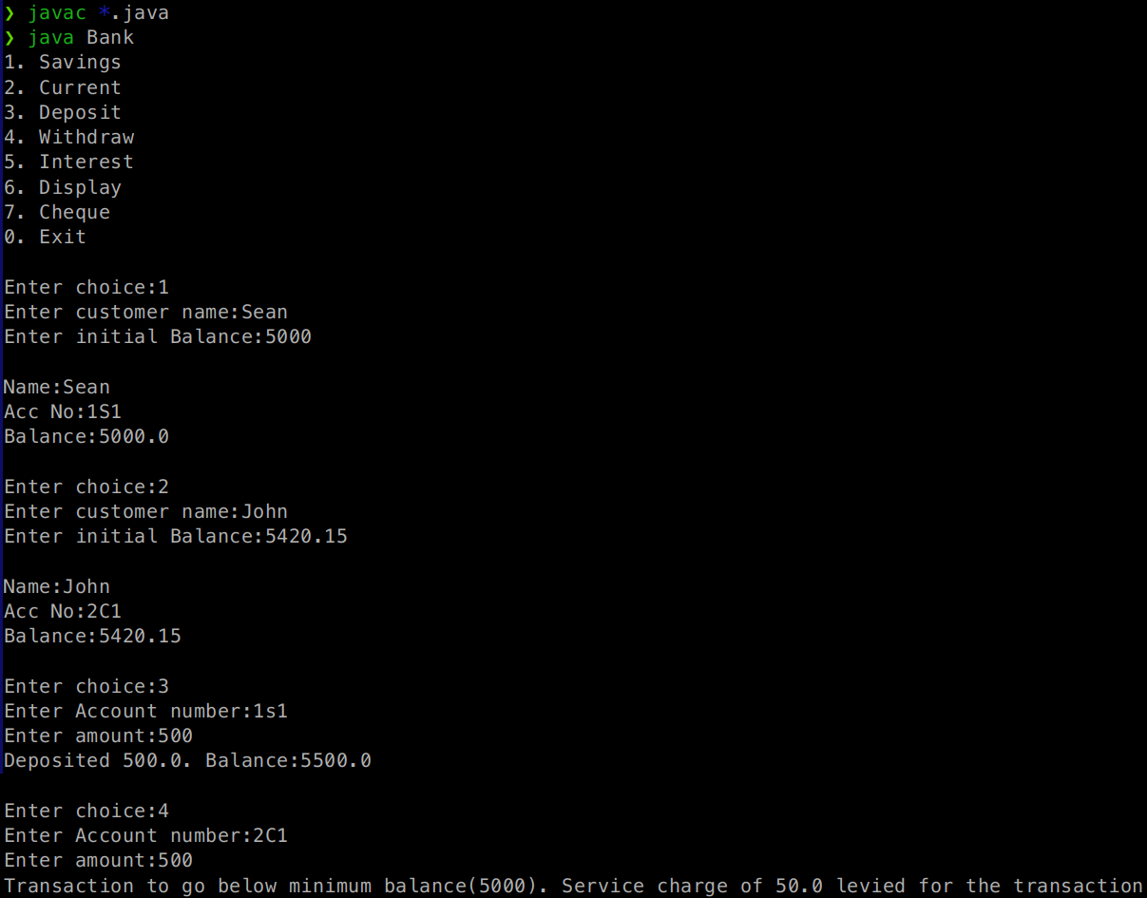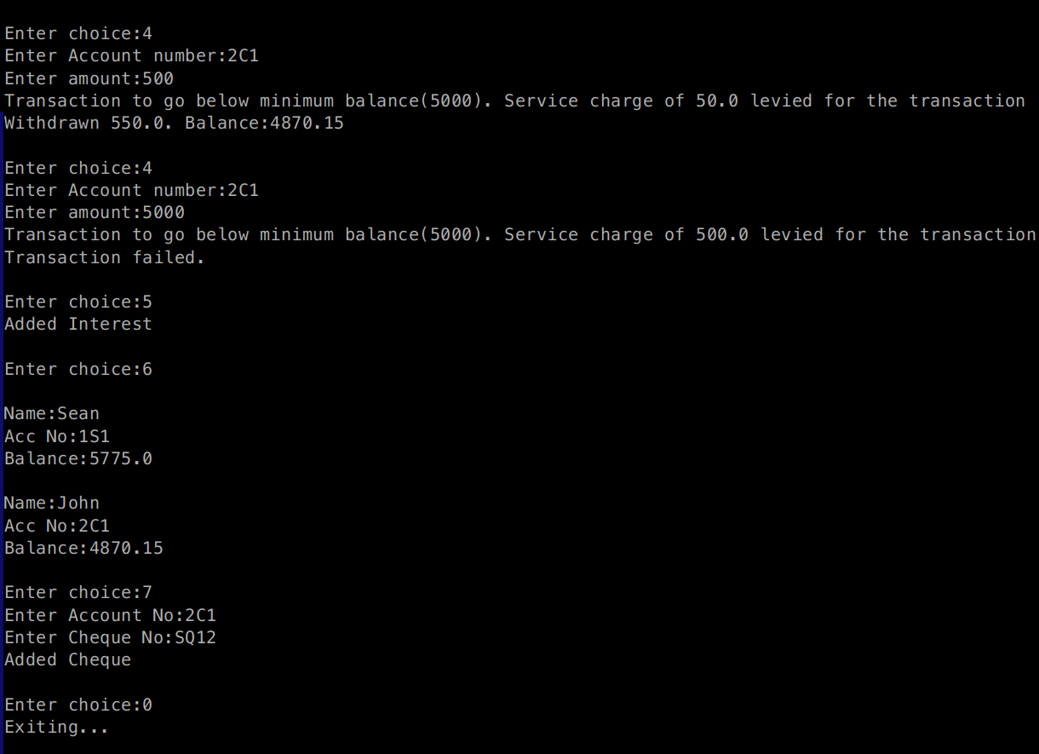

**LABORATORY PROGRAM - 6**

Create a package CIE which has two classes- Student and Internals. The class Personal has members like usn, name, sem. The class internals has an array that stores the internal marks scored in five courses of the current semester of the student. Create another package SEE which has the class External which is a derived class of Student. This class has an array that stores the SEE marks scored in five courses of the current semester of the student. Import the two packages in a file that declares the final marks of n students in all five courses.

.

├── CIE

│ ├── Internals.class

│ ├── Internals.java

│ ├── Student.class

│ └── Student.java

├── Main.class

├── Main.java

└── SEE

├── Externals.class

└── Externals.java

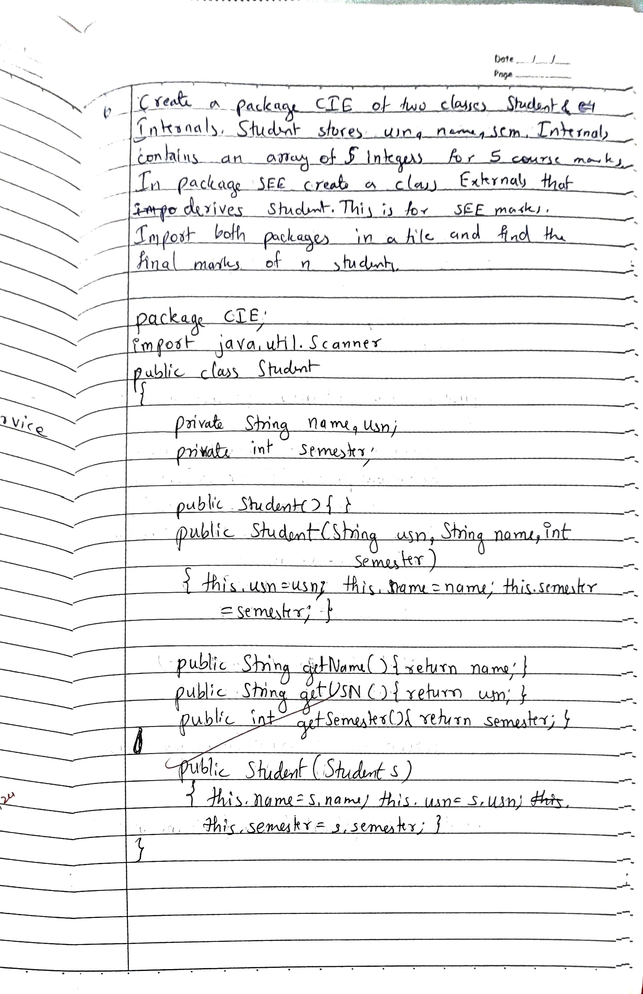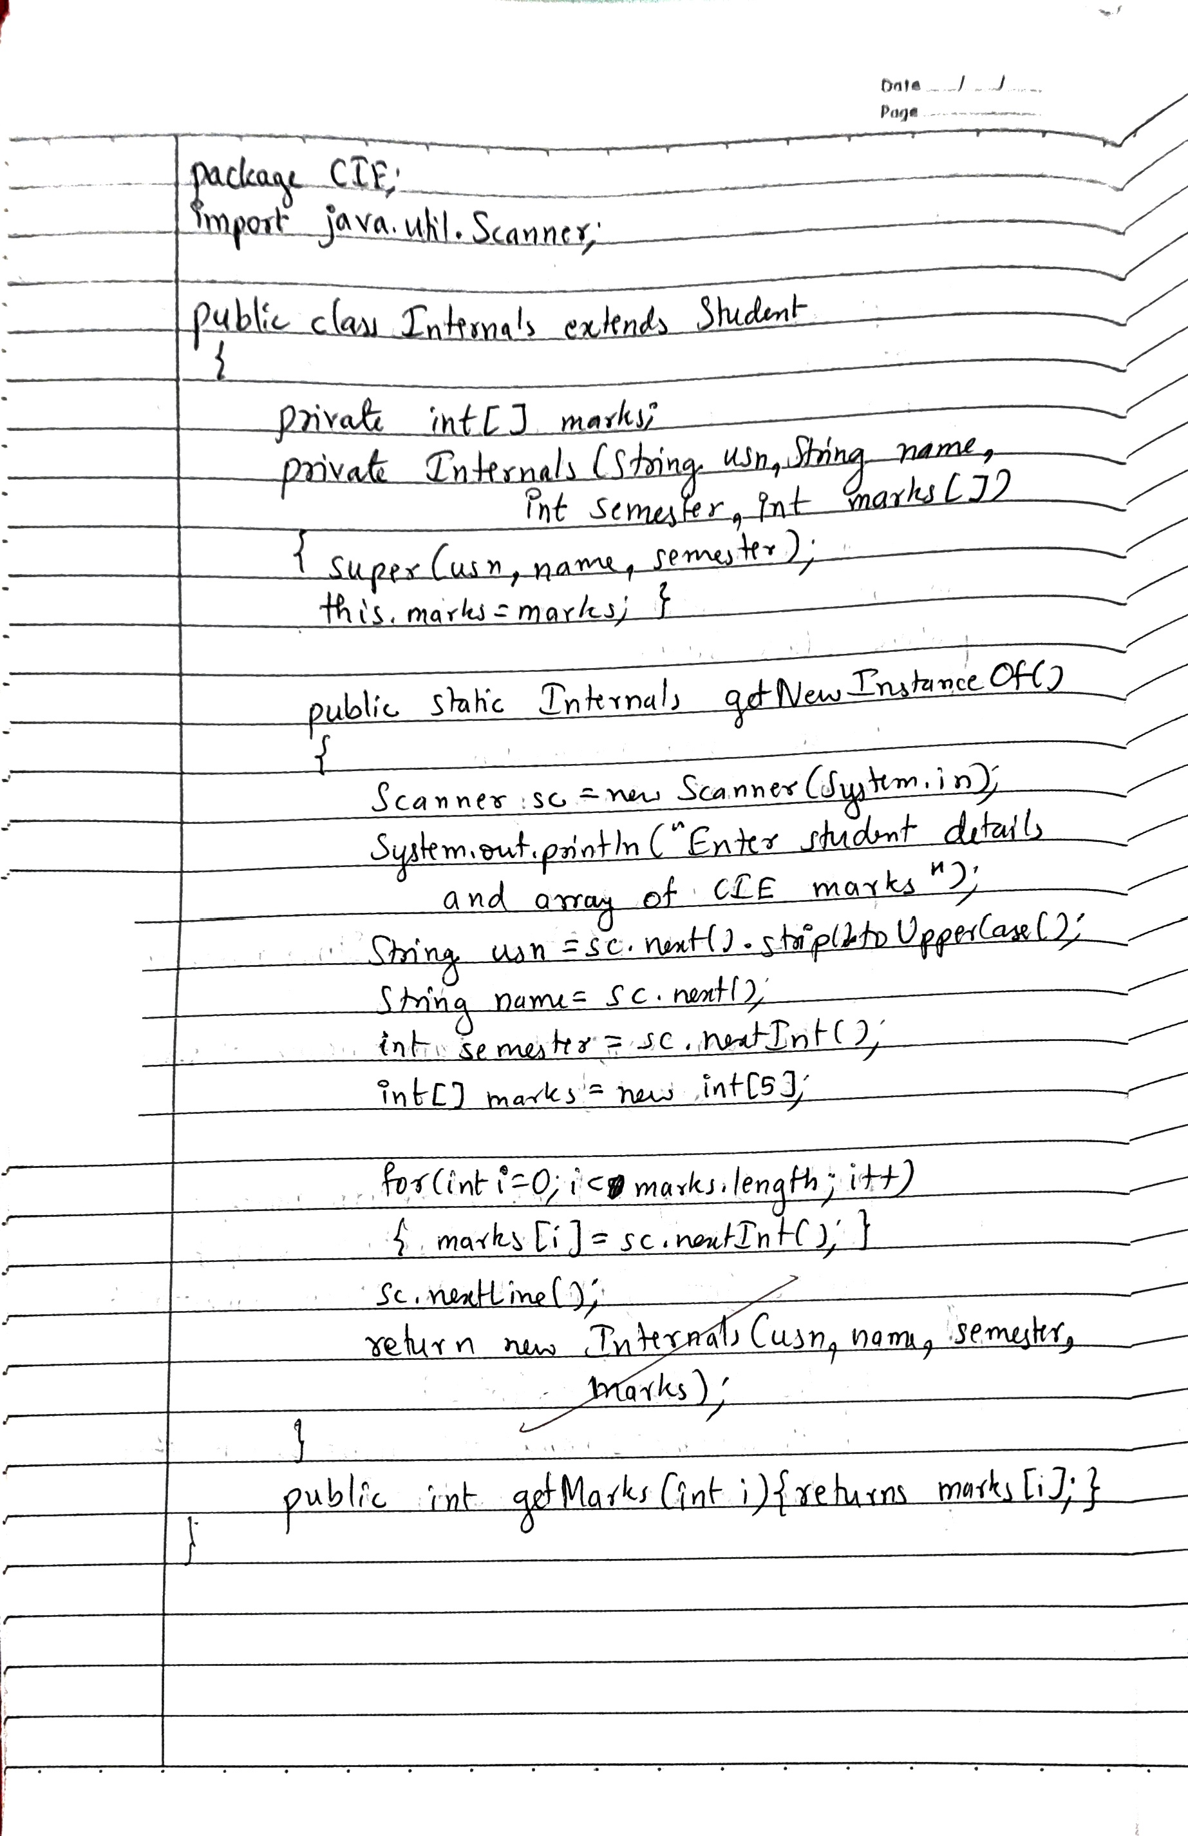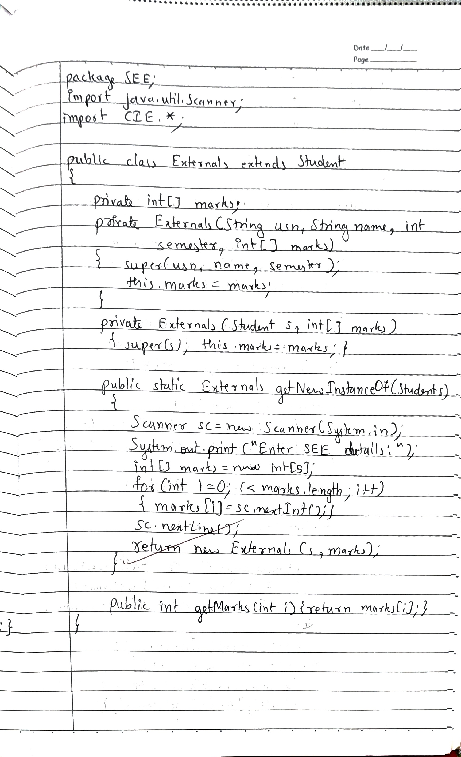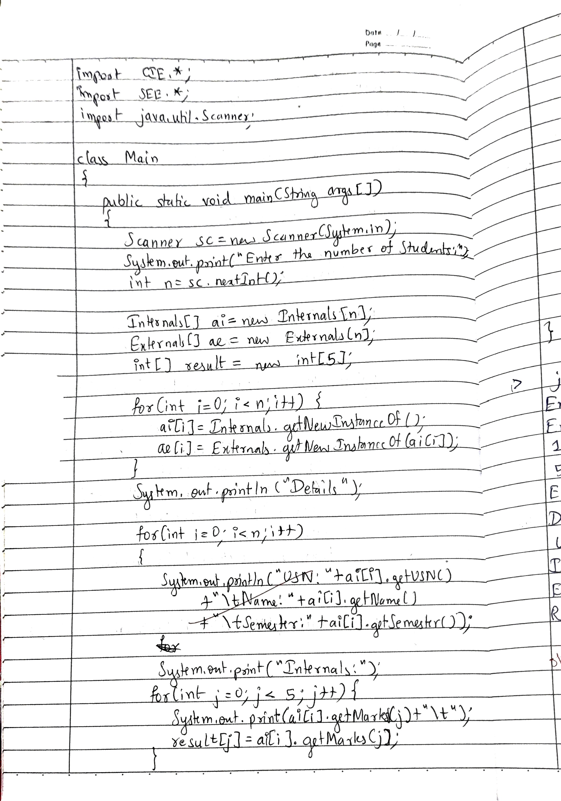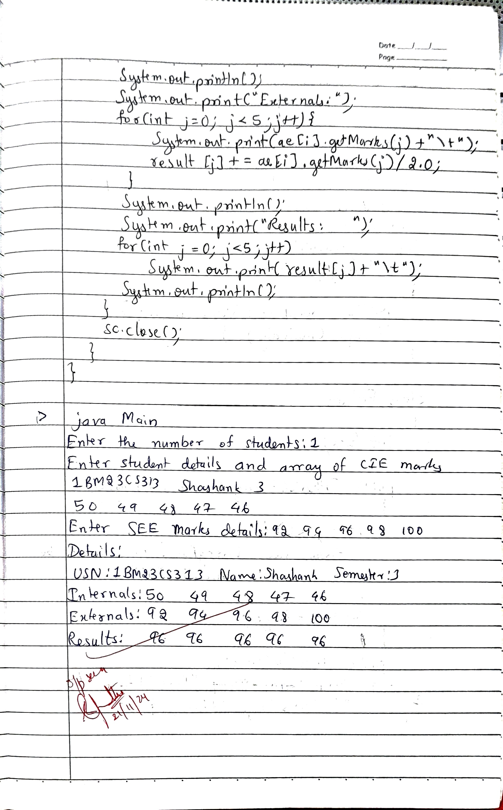

**Code:**

**// CIE/Student.java**

**package CIE;**

**import java.util.Scanner;**

**public class Student**

**{**

**private String name;**

**private String usn;**

**private int semester;**

**public Student(){}**

**public Student(String usn, String name, int semester)**

**{**

**this.usn=usn;**

**this.name=name;**

**this.semester=semester;**

**}**

**public Student(Student s)**

**{**

**this.usn = s.usn;**

**this.name = s.name;**

**this.semester = s.semester;**

**}**

**/\*\***

**public void getData()**

**{**

**Scanner sc = new Scanner(System.in);**

**System.out.print("Enter USN:");**

**this.usn = sc.next().strip().toUpperCase();**

**System.out.print("Enter name:");**

**this.name = sc.nextLine();**

**System.out.print("Enter semester:");**

**this.semester=sc.nextInt();**

**}**

**\*\*/**

**public String getName(){return name;}**

**public String getUSN(){return usn;}**

**public int getSemester(){return semester;}**

**}**

**// CIE/Internals.java**

**package CIE;**

**import java.util.Scanner;**

**public class Internals extends Student**

**{**

**private int[] marks;**

**private Internals(String usn, String name, int semester, int marks[]){**

**super(usn,name,semester);**

**this.marks=marks;**

**}**

**private Internals(Student s, int[] marks)**

**{**

**super(s);**

**this.marks=marks;**

**}**

**/\*\***

**public Internals(int[] marks)**

**{**

**this.marks=marks;**

**}**

**\*\*/**

**public static Internals getNewInstanceOf()**

**{**

**Scanner sc = new Scanner(System.in);**

**System.out.println("Enter student details and array of CIE marks");**

**String usn = sc.next().strip().toUpperCase();**

**String name = sc.next();**

**int semester = sc.nextInt();**

**int[] marks = new int[5];**

**for(int i=0;i<marks.length;i++){**

**marks[i]=sc.nextInt();**

**}**

**sc.nextLine();**

**return new Internals(usn,name,semester,marks);**

**}**

**public static Internals getNewInstanceOf(Student s)**

**{**

**Scanner sc = new Scanner(System.in);**

**System.out.println("Enter CIE marks details:");**

**int marks[] = new int[5];**

**for(int i=0;i<marks.length;i++){**

**marks[i]=sc.nextInt();**

**}**

**sc.nextLine();**

**return new Internals(s,marks);**

**}**

**public int getMarks(int i){return marks[i];}**

**}**

**// SEE/Externals.java**

**package SEE;**

**import java.util.Scanner;**

**import CIE.*;**

**public class Externals extends Student**

**{**

**private int[] marks;**

**private Externals(String usn, String name, int semester, int[] marks){**

**super(usn,name,semester);**

**this.marks=marks;**

**}**

**private Externals(Student s, int[] marks)**

**{**

**super(s);**

**this.marks=marks;**

**}**

**/\*\***

**public Externals(int[] marks)**

**{**

**this.marks=marks;**

**}**

**\*\*/**

**public static Externals getNewInstanceOf() {**

**Scanner sc = new Scanner(System.in);**

**System.out.println("Enter student details and array of SEE marks");**

**String usn = sc.next().strip().toUpperCase();**

**String name = sc.next();**

**int semester = sc.nextInt();**

**int[] marks = new int[5];**

**for (int i = 0; i < marks.length; i++) {**

**marks[i] = sc.nextInt();**

**}**

**sc.nextLine();**

**return new Externals(usn, name, semester, marks);**

**}**

**public static Externals getNewInstanceOf(Student s) {**

**Scanner sc = new Scanner(System.in);**

**System.out.print("Enter SEE marks details:");**

**int[] marks = new int[5];**

**for (int i = 0; i < marks.length; i++) {**

**marks[i] = sc.nextInt();**

**}**

**sc.nextLine();**

**return new Externals(s, marks);**

**}**

**public int getMarks(int i){return marks[i];}**

**}**

**// Main.java**

**import CIE.*;**

**import SEE.*;**

**import java.util.Scanner;**

**class Main**

**{**

**public static void main(String args[])**

**{**

**Scanner sc = new Scanner(System.in);**

**System.out.print("Enter the number of Students:");**

**int n = sc.nextInt();**

**Internals[] ai = new Internals[n];**

**Externals[] ae = new Externals[n];**

**int[] result=new int[5];**

**for (int i = 0; i < n; i++) {**

**ai[i] = Internals.getNewInstanceOf();**

**ae[i] = Externals.getNewInstanceOf(ai[i]);**

**}**

**System.out.println("Details:");**

**for(int i=0;i<n;i++)**

**{**

**System.out.println("USN:"+ai[i].getUSN()**

**+"\tName:"+ai[i].getName()**

**+"\tSemester:"+ai[i].getSemester());**

**System.out.print("Internals:");**

**for(int j=0;j<5;j++){**

**System.out.print(ai[i].getMarks(j)+"\t");**

**result[j]=ai[i].getMarks(j);**

**}**

**System.out.println();**

**System.out.print("Externals:");**

**for(int j=0;j<5;j++){**

**System.out.print(ae[i].getMarks(j)+"\t");**

**result[j]+=ae[i].getMarks(j)/2.0;**

**}**

**System.out.println();**

**System.out.print("Results: ");**

**for(int j=0;j<5;j++)**

**System.out.print(result[j]+"\t");**

**System.out.println();**

**}**

**sc.close();**

**}**

**}**

**OUTPUT**

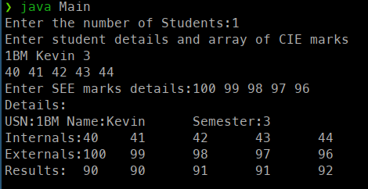

**LABORATORY PROGRAM - 7**

Write a program that demonstrates handling of exceptions in inheritance tree. Create a base class called “Father” and derived class called “Son” which extends the base class. In Father class, implement a constructor which takes the age and throws the exception WrongAge( ) when the input age<0. In Son class, implement a constructor that uses both father and son’s age and throws an exception if son’s age is >=father’s age.

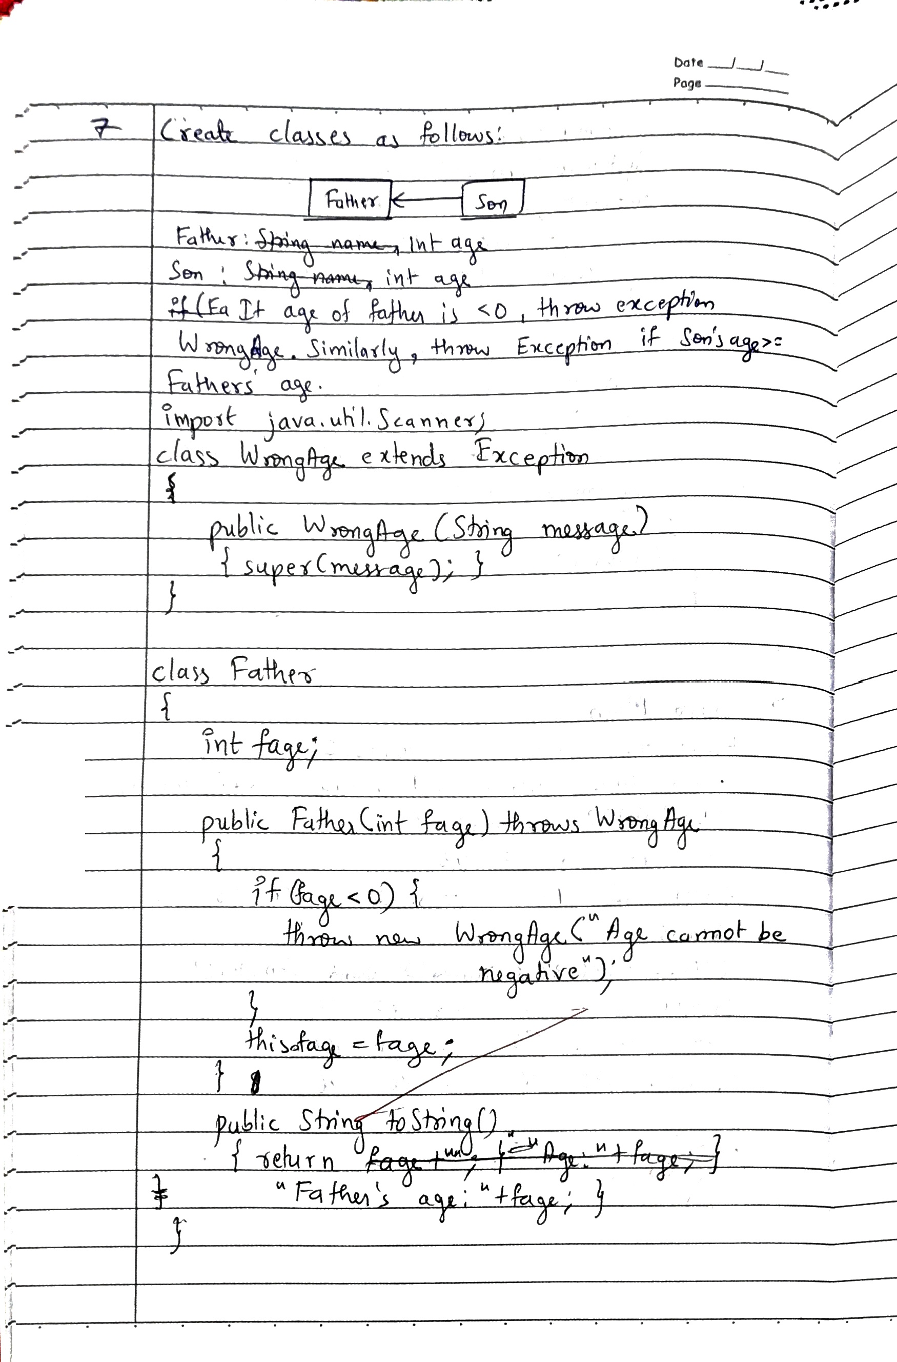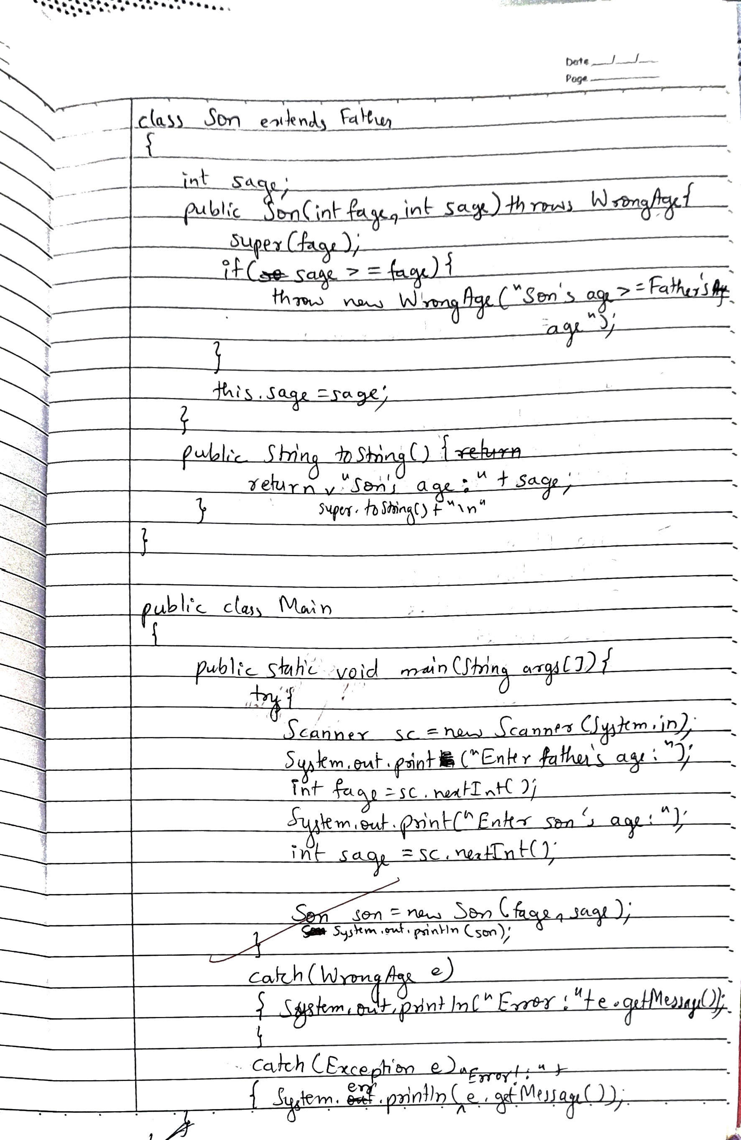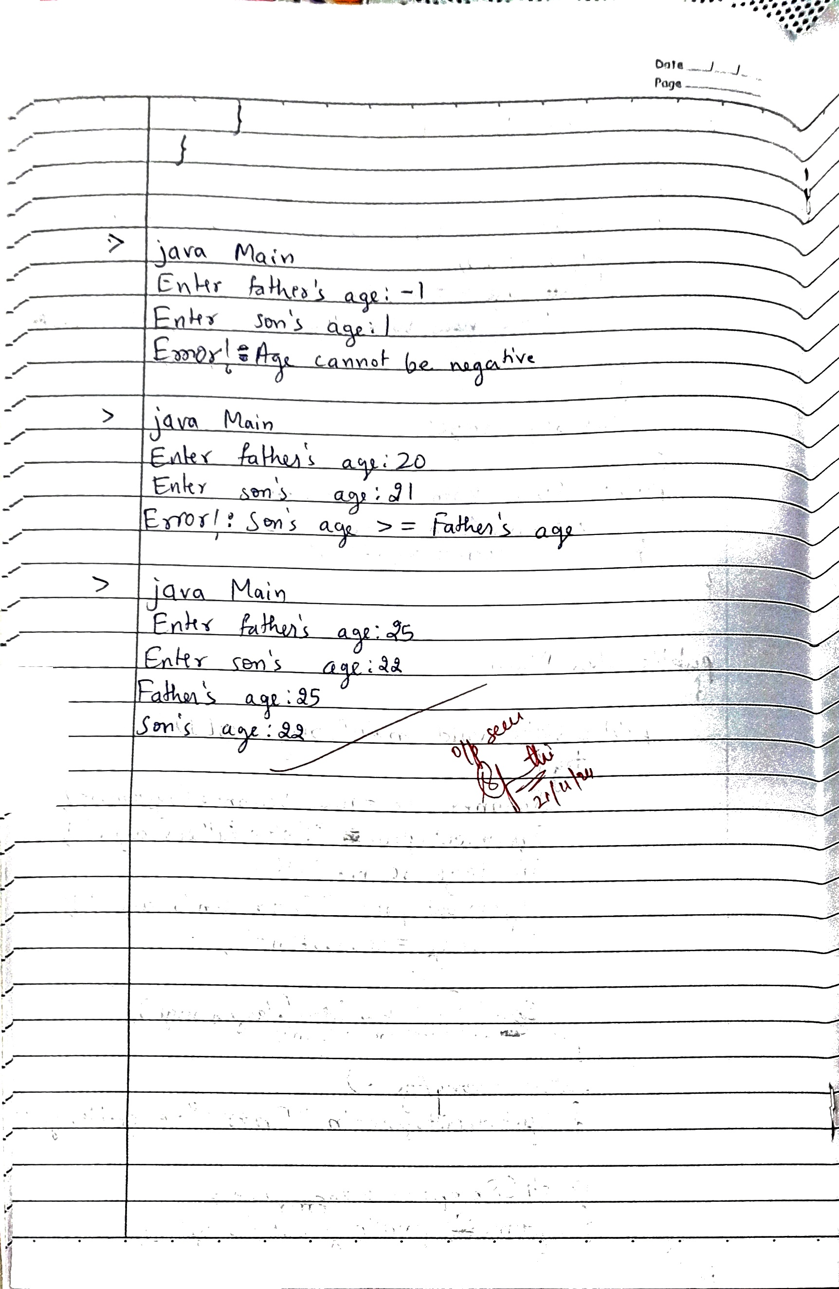

**Code:**

**import java.util.Scanner;**

**class WrongAge extends Exception**

**{**

**public WrongAge(String message)**

**{super(message);}**

**}**

**class Father**

**{**

**int fage;**

**public Father(int fage) throws WrongAge{**

**if(fage<0)**

**{throw new WrongAge("Age cannot be negative");}**

**this.fage=fage;**

**}**

**public String toString(){**

**return "Father\'s age:"+fage;**

**}**

**}**

**class Son extends Father**

**{**

**int sage;**

**public Son(int fage, int sage) throws WrongAge**

**{**

**super(fage);**

**if(sage>=fage)**

**{throw new WrongAge("Son\'s age >= Father\'s age");}**

**this.sage=sage;**

**}**

**public String toString()**

**{ return super.toString()+"\n"+"Son\'s age:"+sage;}**

**}**

**public class Main**

**{**

**public static void main(String args[])**

**{**

**try{**

**Scanner sc = new Scanner(System.in);**

**System.out.print("Enter father\'s age:");**

**int fage=sc.nextInt();**

**System.out.print("Enter son\'s age:");**

**int sage=sc.nextInt();**

**Son son = new Son(fage, sage);**

**System.out.println(son);**

**}**

**catch(WrongAge e)**

**{System.err.println("Error!:"+e.getMessage());}**

**}**

**}**

**OUTPUT**

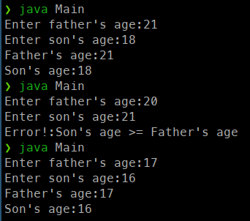

**LABORATORY PROGRAM - 8**

Write a program which creates two threads, one thread displaying “BMS College of Engineering” once every ten seconds and another displaying “CSE” once every two seconds.

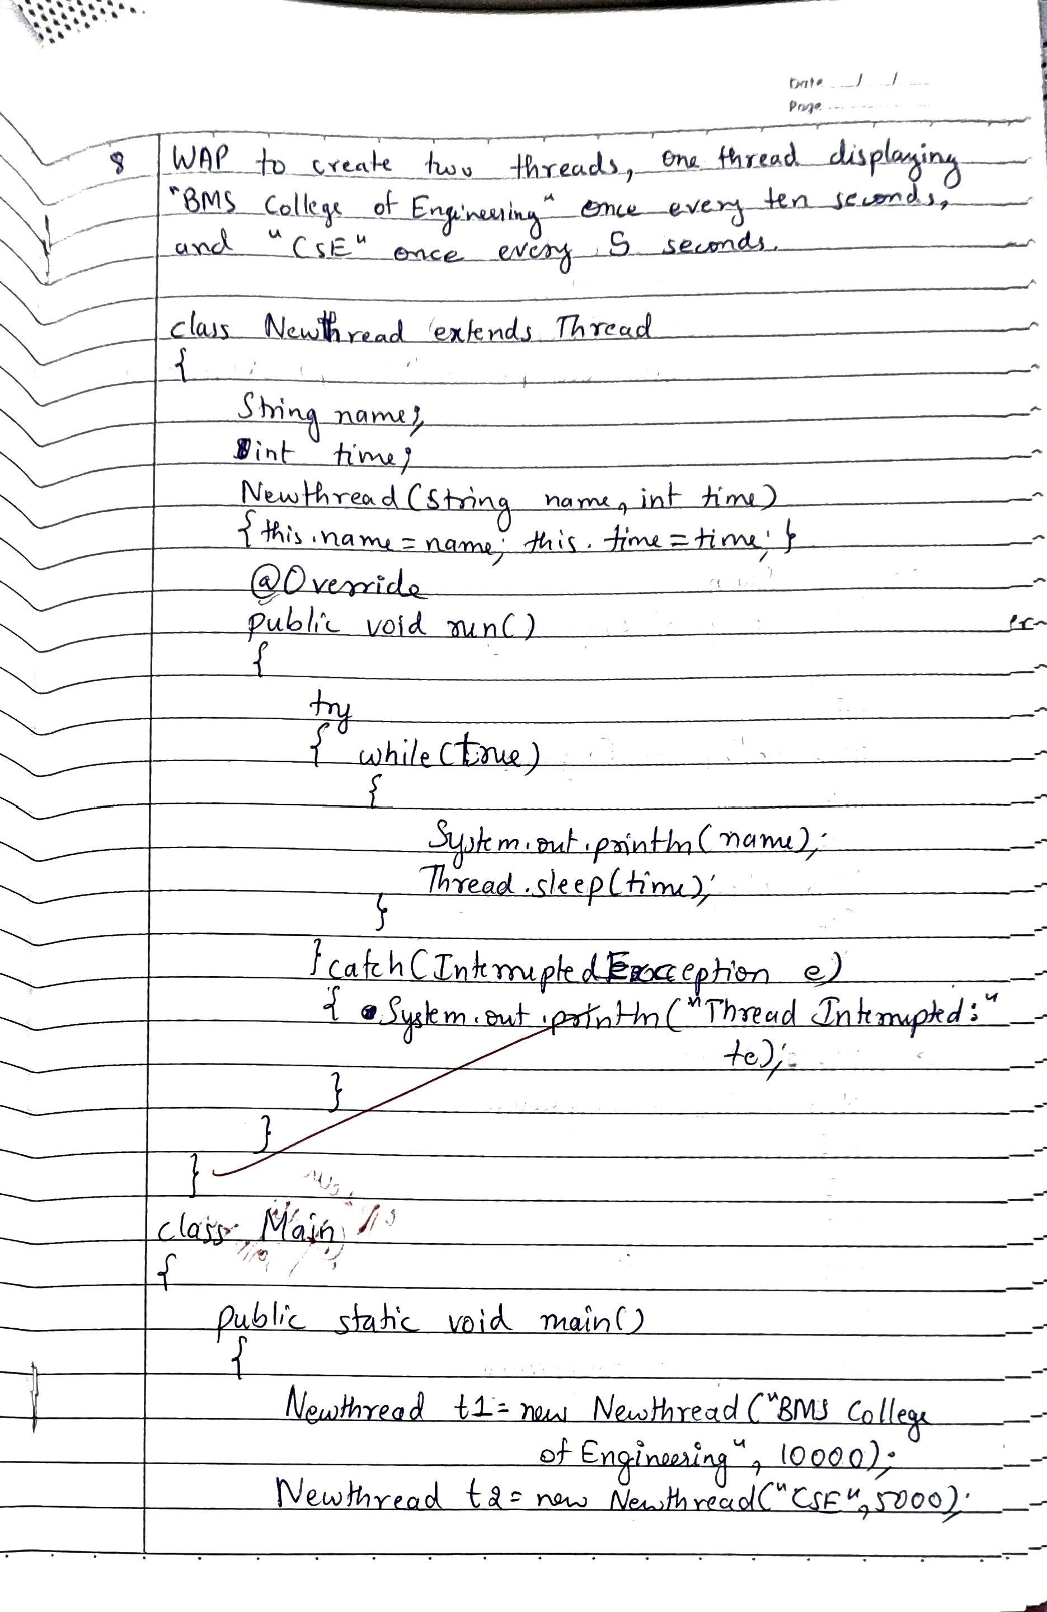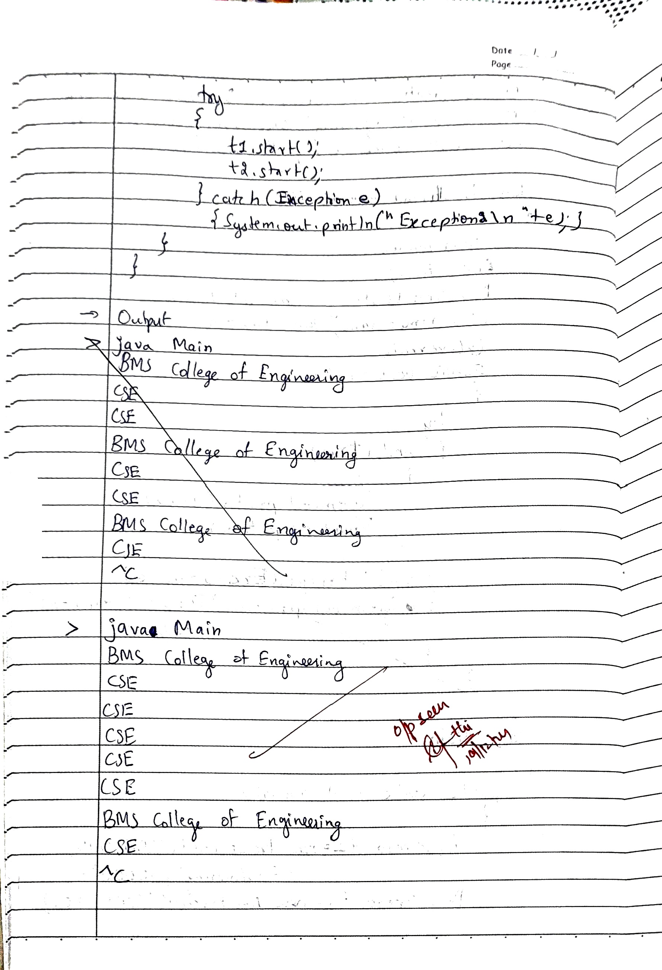

**Code:**

**class Newthread extends Thread**

**{**

**String name;**

**int time;**

**Newthread(String name, int time)**

**{**

**this.name=name;**

**this.time=time;**

**}**

**@Override**

**public void run()**

**{**

**try**

**{**

**while(true)**

**{**

**System.out.println(name);**

**Thread.sleep(time);**

**}**

**}**

**catch(InterruptedException e)**

**{System.out.println("Thread interrupted:\n"+e);}**

**}**

**}**

**public class Main**

**{**

**public static void main(String[] args)**

**{**

**Newthread t1 = new Newthread("BMS College of Engineering",10000);**

**Newthread t2 = new Newthread("CSE",2000);**

**try**

**{**

**t1.start();**

**t2.start();**

**}**

**catch(Exception e)**

**{System.out.println("Exception\n"+e);}**

**}**

**}**

**OUTPUT**

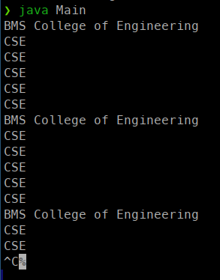

**LABORATORY PROGRAM - 9**

Write a program that creates a user interface to perform integer divisions. The user enters two numbers in the text fields, Num1 and Num2. The division of Num1 and Num2 is displayed in the Result field when the Divide button is clicked. If Num1 or Num2 were not an integer, the program would throw a NumberFormatException. If Num2 were Zero, the program would throw an Arithmetic Exception Display the exception in a message dialog box.

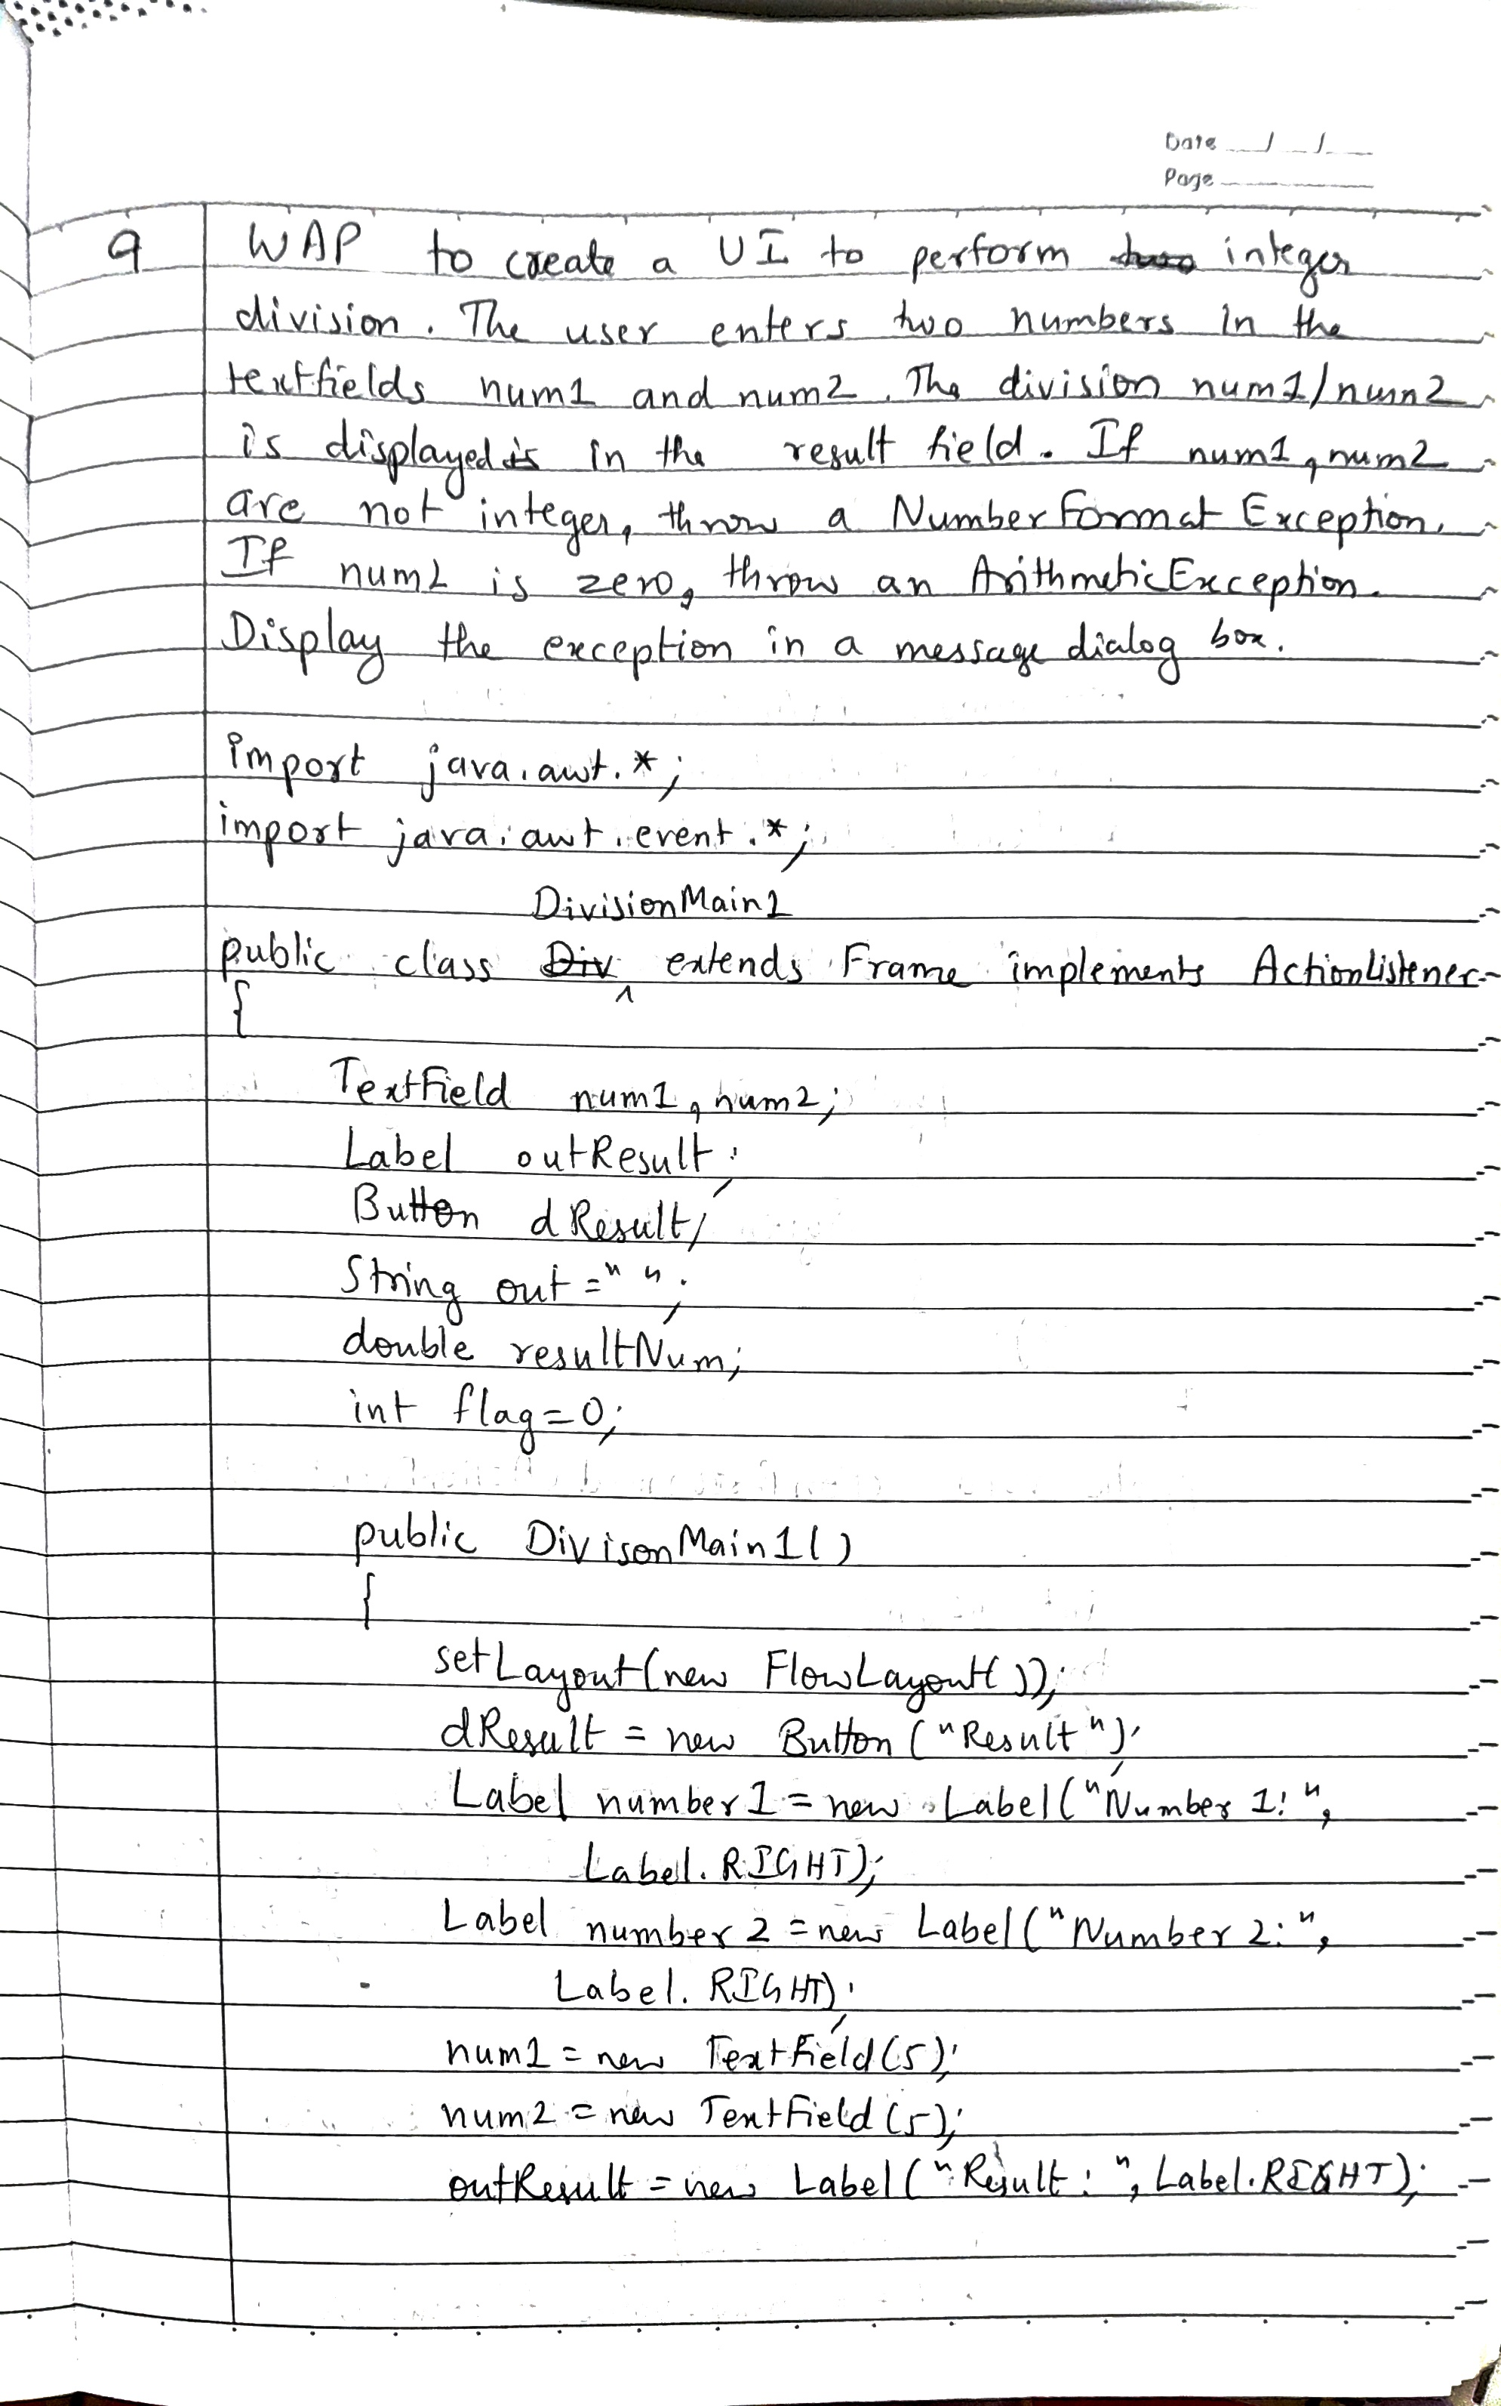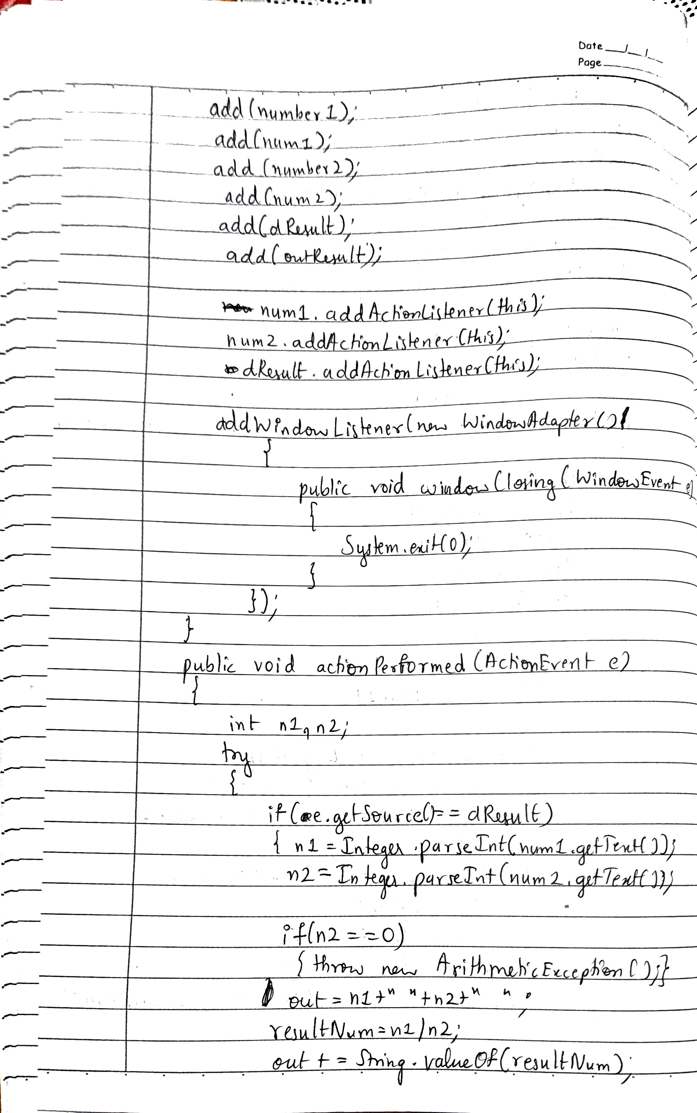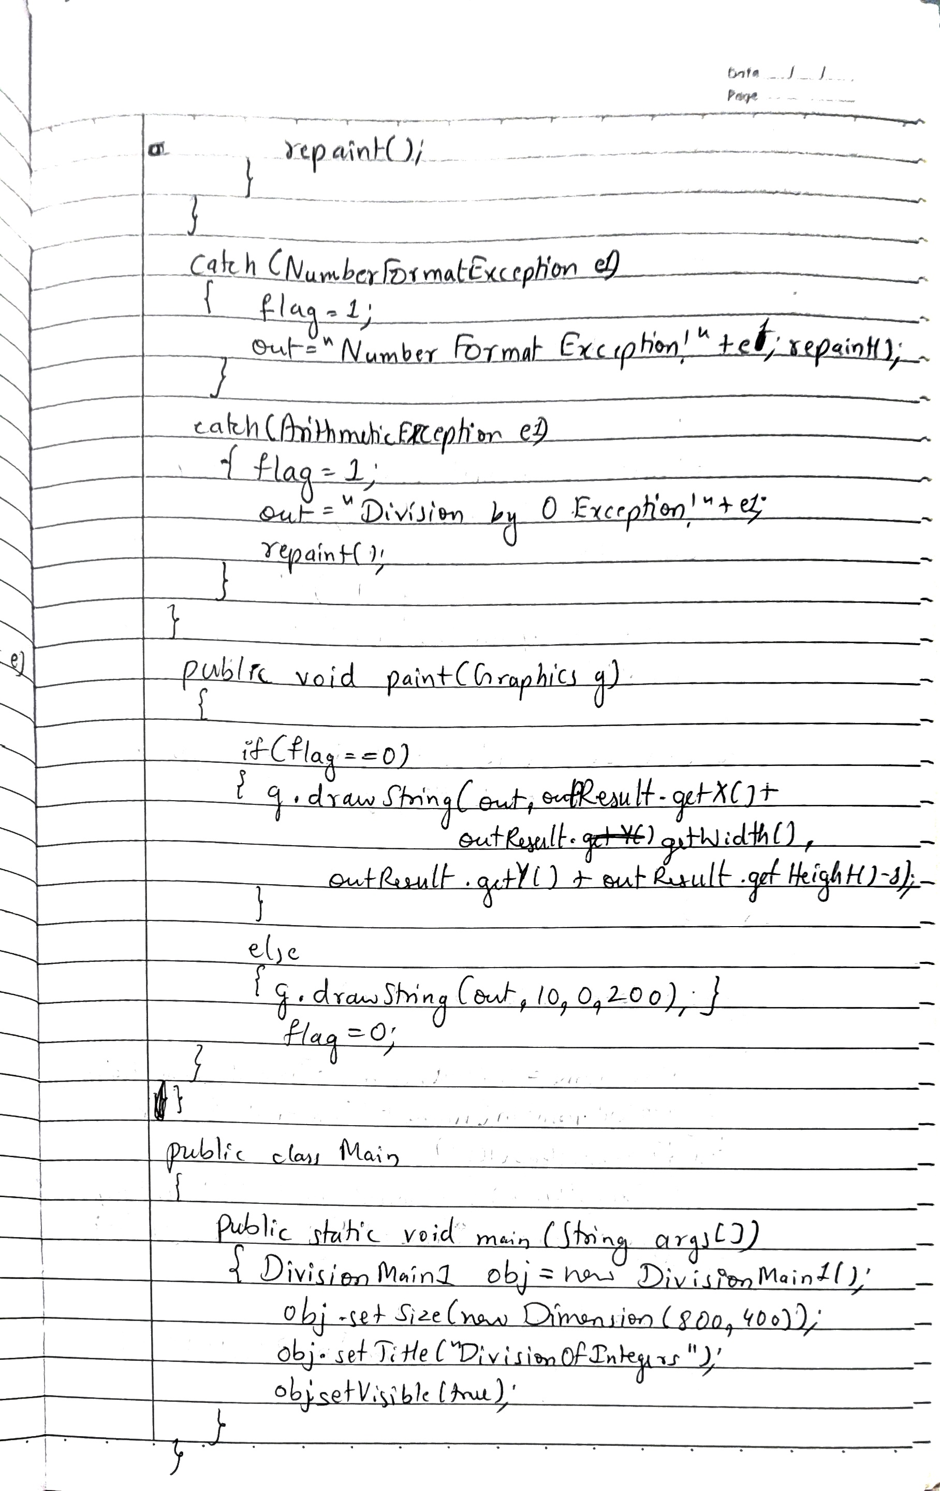

**Code:**

**import java.awt.*;**

**import java.awt.event.*;**

**class DivisionMain1 extends Frame implements ActionListener**

**{**

**TextField num1,num2;**

**Button dResult;**

**Label outResult;**

**String out="";**

**double resultNum;**

**int flag=0;**

**public DivisionMain1()**

**{**

**setLayout(new FlowLayout());**

**dResult = new Button("Result:");**

**Label number1 = new Label("Number 1:",Label.RIGHT);**

**Label number2 = new Label("Number 2:",Label.RIGHT);**

**num1=new TextField(5);**

**num2=new TextField(5);**

**outResult = new Label("",Label.RIGHT);**

**add(number1);**

**add(num1);**

**add(number2);**

**add(num2);**

**add(dResult);**

**add(outResult);**

**num1.addActionListener(this);**

**num2.addActionListener(this);**

**dResult.addActionListener(this);**

**addWindowListener(new WindowAdapter(){**

**public void windowClosing(WindowEvent e)**

**{**

**System.exit(0);**

**}**

**});**

**}**

**public void actionPerformed(ActionEvent e)**

**{**

**int n1,n2;**

**try**

**{**

**if (e.getSource() == dResult)**

**{**

**n1=Integer.parseInt(num1.getText());**

**n2=Integer.parseInt(num2.getText());**

**if(n2==0)**

**{throw new ArithmeticException();}**

**out=n1+"/"+n2+" ";**

**resultNum=n1/n2;**

**out+=resultNum;**

**}**

**}**

**catch(NumberFormatException e1)**

**{**

**flag=1;**

**out="Number Format Exception!"+e1;**

**}**

**catch(ArithmeticException e1)**

**{**

**flag=1;**

**out="Divide by 0 Exception!"+e1;**

**}**

**outResult.setText(out);**

**invalidate();**

**validate();**

**}**

**//public void paint(Graphics g)**

**//{**

**// if(flag==0)**

**// {g.drawString(out,dResult.getX()+dResult.getWidth(),dResult.getY()+outResult.getHeight()-8);}**

**// else**

**// {g.drawString(out,100,200); flag=0;}**

**//}**

**}**

**public class Main**

**{**

**public static void main(String args[])**

**{**

**DivisionMain1 obj=new DivisionMain1();**

**obj.setSize(new Dimension(800,400));**

**obj.setTitle("DivisionOfIntegers");**

**obj.setVisible(true);**

**}**

**}**

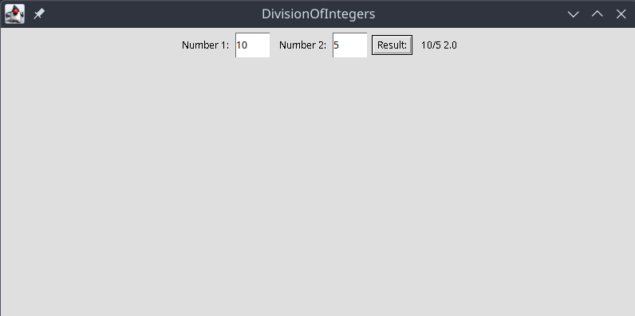

**LABORATORY PROGRAM - 10**

Demonstrate Interprocess Communication and deadlock.

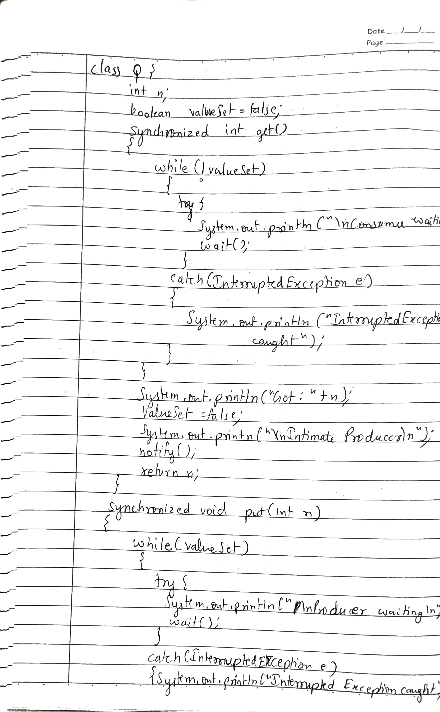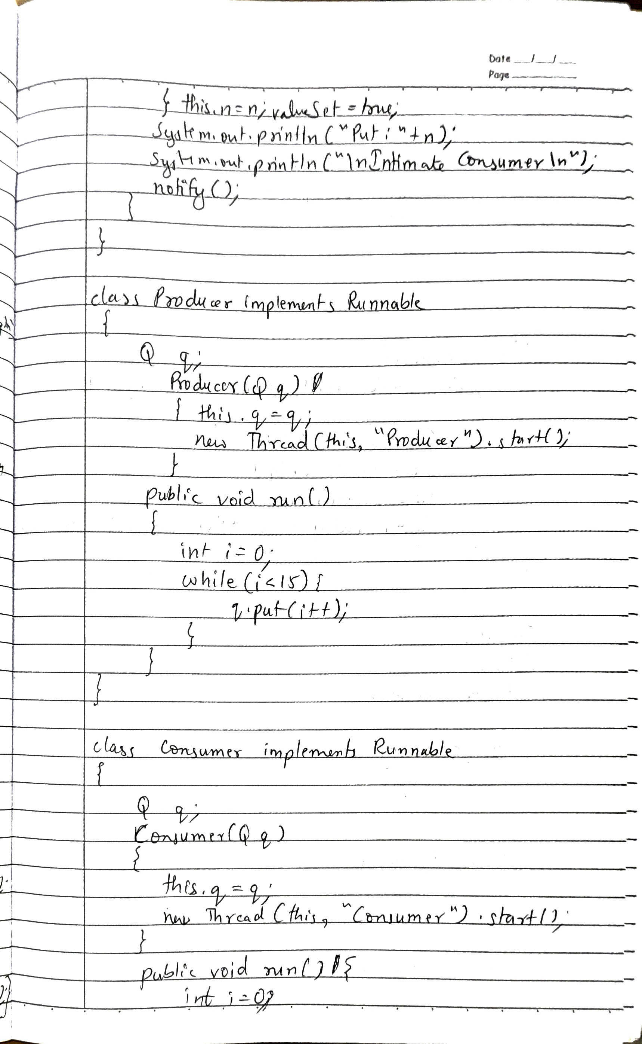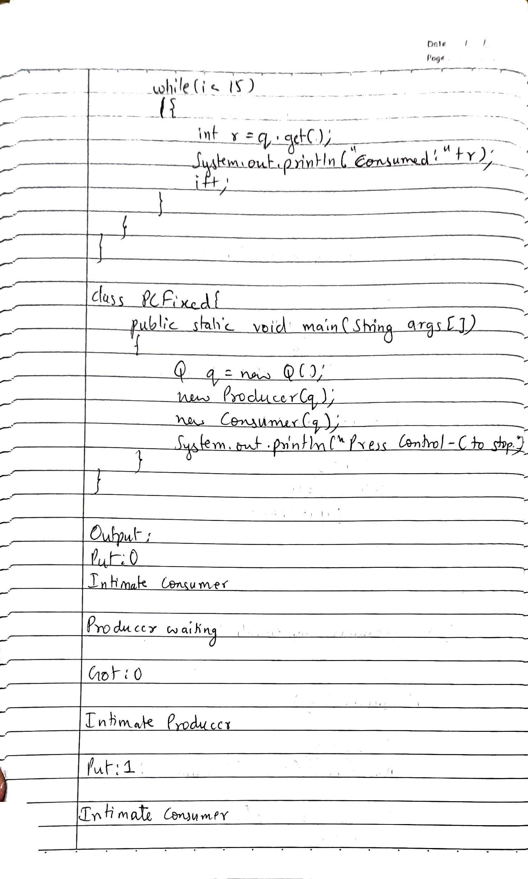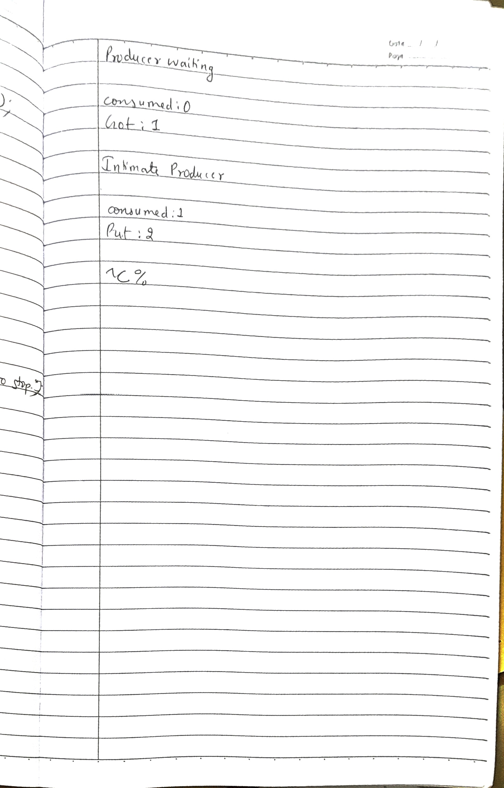

**Code:**

**class Q {**

**int n;**

**boolean valueSet = false;**

**synchronized int get() {**

**while(!valueSet){**

**try {**

**System.out.println("\nConsumer waiting\n");**

**wait();**

**}**

**catch(InterruptedException e) {**

**System.out.println("InterruptedException caught");**

**}**

**}**

**System.out.println("Got: " + n);**

**valueSet = false;**

**System.out.println("\nIntimate Producer\n");**

**notify();**

**return n;**

**}**

**synchronized void put(int n) {**

**while(valueSet){**

**try {**

**System.out.println("\nProducer waiting\n");**

**wait();**

**}**

**catch(InterruptedException e) {**

**System.out.println("InterruptedException caught");**

**}**

**}**

**this.n = n;**

**valueSet = true;**

**System.out.println("Put: " + n);**

**System.out.println("\nIntimate Consumer\n");**

**notify();**

**}**

**}**

**class Producer implements Runnable {**

**Q q;**

**Producer(Q q) {**

**this.q = q;**

**new Thread(this, "Producer").start();**

**}**

**public void run() {**

**int i = 0;**

**while(i<15) {**

**q.put(i++);**

**}**

**}**

**}**

**class Consumer implements Runnable {**

**Q q;**

**Consumer(Q q) {**

**this.q = q;**

**new Thread(this, "Consumer").start();**

**}**

**public void run() {**

**int i=0;**

**while(i<15) {**

**int r=q.get();**

**System.out.println("consumed:"+r);**

**i++;**

**}**

**}**

**}**

**class PCFixed {**

**public static void main(String args[]) {**

**Q q = new Q();**

**new Producer(q);**

**new Consumer(q);**

**System.out.println("Press Control-C to stop.");**

**}**

**}**

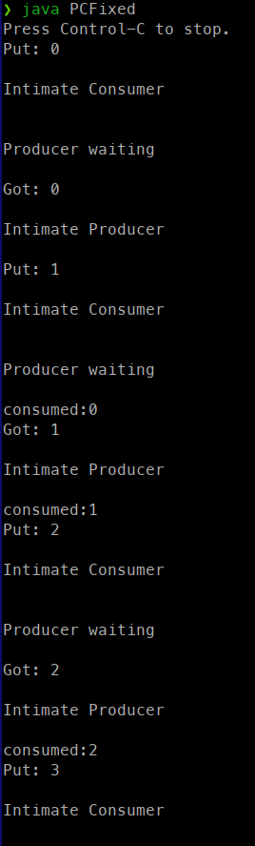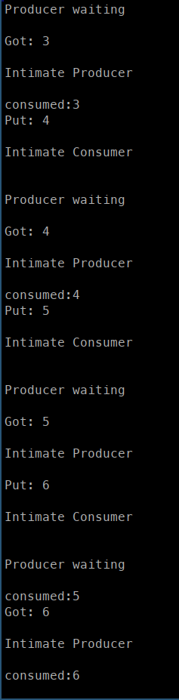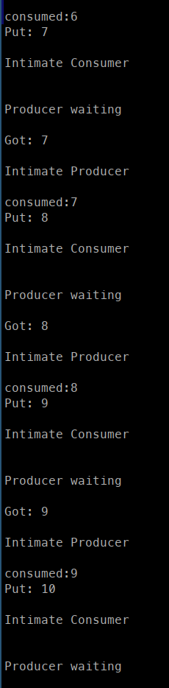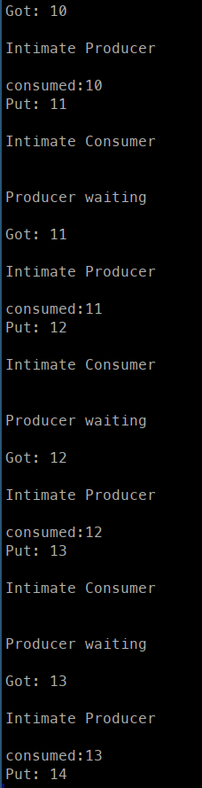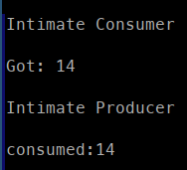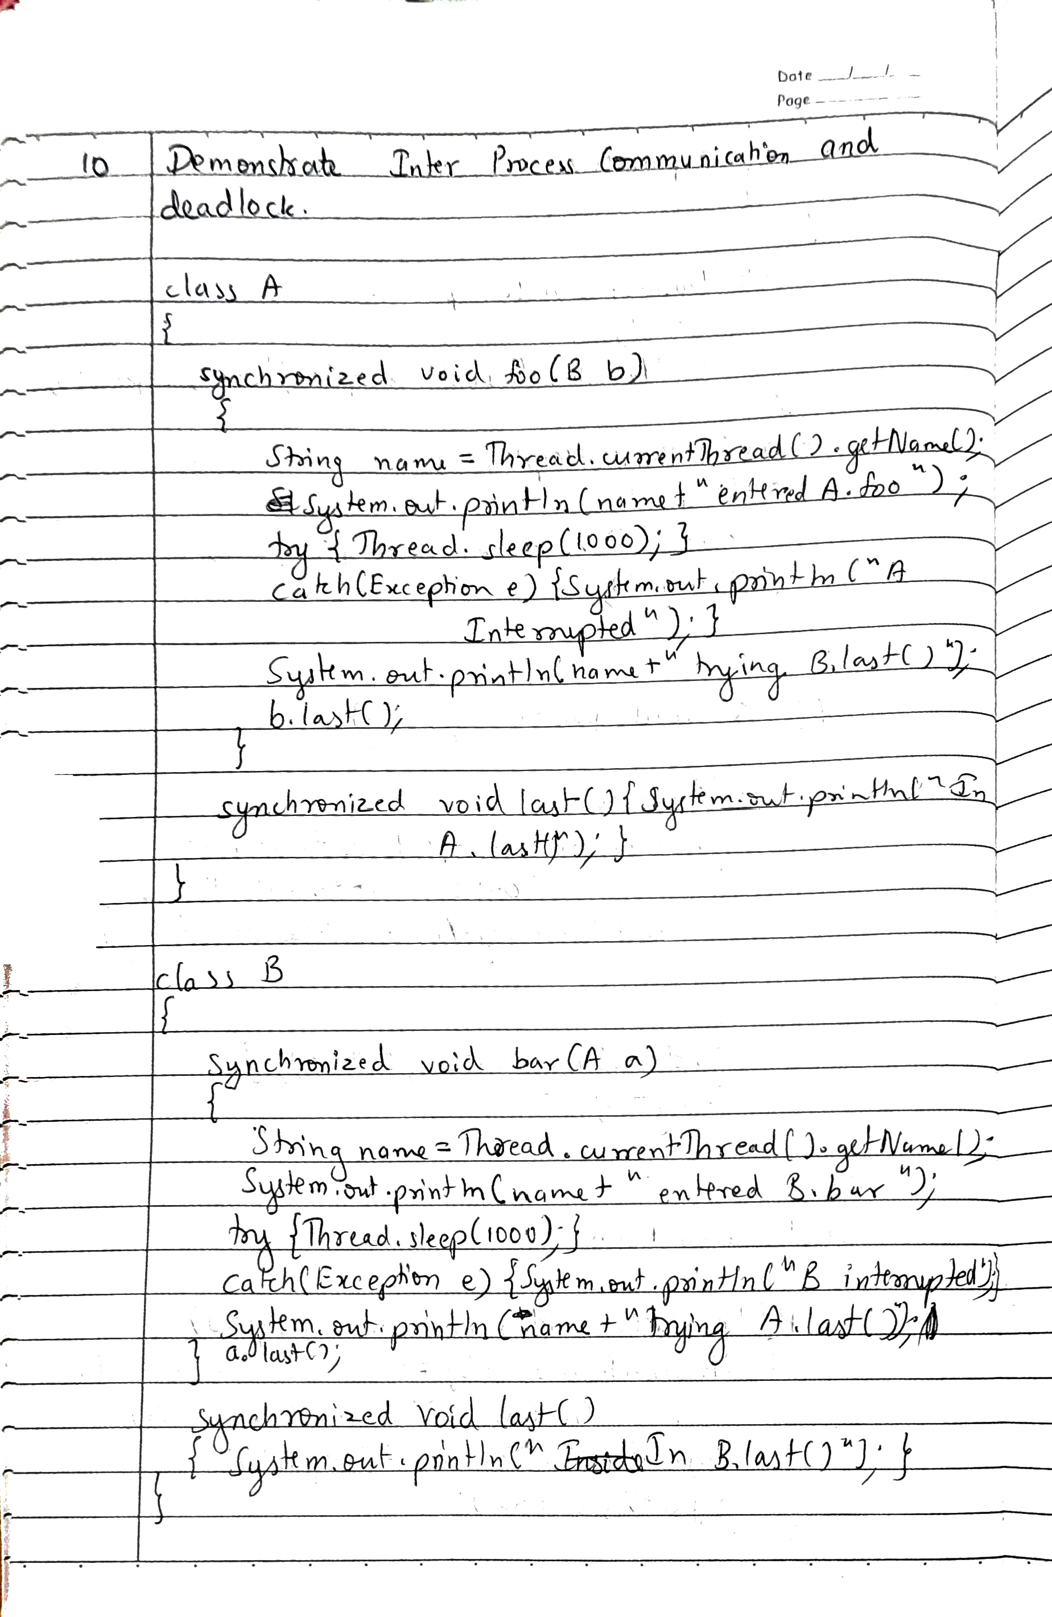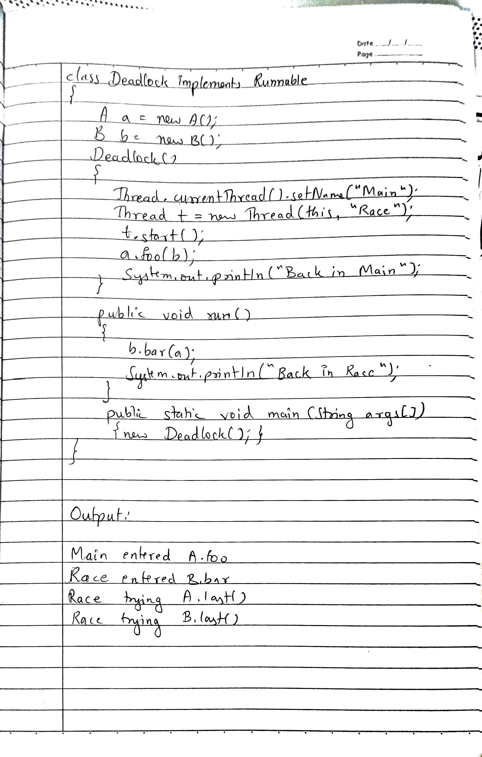

**Code:**

**class A**

**{**

**synchronized void foo(B b)**

**{**

**String name = Thread.currentThread().getName();**

**System.out.println(name + " entered A.foo");**

**try { Thread.sleep(1000); }**

**catch(Exception e) { System.out.println("A Interrupted"); }**

**System.out.println(name + " trying B.last()");**

**b.last();**

**}**

**synchronized void last() { System.out.println("In A.last()"); }**

**}**

**class B {**

**synchronized void bar(A a) {**

**String name = Thread.currentThread().getName();**

**System.out.println(name + " entered B.bar");**

**try { Thread.sleep(1000); }**

**catch(Exception e) { System.out.println("B Interrupted"); }**

**System.out.println(name + " trying A.last()");**

**a.last();**

**}**

**synchronized void last() { System.out.println("In B.last()"); }**

**}**

**class Deadlock implements Runnable**

**{**

**A a = new A();**

**B b = new B();**

**Deadlock() {**

**Thread.currentThread().setName("Main");**

**Thread t = new Thread(this, "Race");**

**t.start(); a.foo(b); // get lock on a in this thread.**

**System.out.println("Back in Main");**

**}**

**public void run() {**

**b.bar(a); // get lock on b in other thread.**

**System.out.println("Back in Race");**

**}**

**public static void main(String args[]) { new Deadlock(); }**

**}**

